
INDUSTRY REPORT
Agriculture, Forestry, Fishing & Hunting in the US
Mar 2026

About

IBISWorld
IBISWorld specializes in industry research with coverage on thousands of global industries. Our comprehensive data and in-depth analysis help businesses of all types gain quick and actionable insights on industries around the world. Busy professionals can spend less time researching and preparing for meetings, and more time focused on making strategic business decisions.

Table Of Contents | Standard

1. About 4
Codes 4
Definition 4
Related Terms 4
What's Included 5
Companies 5
Related Industries 5
Additional Resources 5
2. At a Glance 6
Key Takeaways 6
Products and Services 7
Major Players 8
Key External Drivers 9
Industry Structure 9
SWOT 10
Executive Summary 10
3. Performance 12
Highlights 12
Key Takeaways 12
Performance Snapshot 13
Outlook 22
Life Cycle 26
4. Products and Markets 27
Key Takeaways 27
Products and Services 28
Major Markets 33
International Trade 36
Imports 39
Exports 40
5. Geographic Breakdown 41
Key Takeaways 41
Business Locations 42
6. Competitive Forces 47
Key Takeaways 47
Concentration 47
Barriers to Entry 49
Substitutes 50
Buyer & Supplier Power 51
7. Companies 54
Key Takeaways 54
Market Share 55
Companies 56
8. External Environment 59
Key Takeaways 59
External Drivers 59
Regulation & Policy 62
Assistance 64
9. Financial Benchmarks 66
Key Takeaways 66
Cost Structure 66
Key Ratios 70
10. Key Statistics 71
Industry Data 71

1. About
https://my.ibisworld.com/us/en/industry/11/about

Codes
NAICS 2017 - USA | 11
NAICS 2022 - USA | 11

Definition
This sector includes farms that primarily grow crops or raise livestock, as well as companies specializing in forestry and agricultural support services. This sector also includes companies that provide land for hunting and fishing.

Related Terms

AGRIBUSINESS
Includes farming, seed supply, agrichemicals, farm machinery, wholesale and distribution, processing, marketing and retail sales.

BIOFUEL
Also called agrifuel, a solid, liquid or gas fuel consisting of, or derived from biological material, usually plants.

BUSHEL
A unit of mass. A bushel of corn equates to 56.0 lb. or 25.4 kg.

ETHANOL
A volatile, flammable liquid. The largest use of ethanol is as a motor fuel and fuel additive.

FERTILIZER
Chemical compounds given to plants to promote growth; usually applied through the soil, for uptake by plant roots.

GENETICALLY MODIFIED (GM)
GM organisms (GMO) have had their DNA altered through genetic engineering.

HERBICIDE
Used to destroy unwanted plants. Selective herbicides destroy specific targets while leaving the desired crop relatively unharmed.

ORGANIC FARMING
A form of agriculture that excludes the use of synthetic fertilizers and pesticides, feed additives and GMOs.

PESTICIDE
A substance used to exterminate a pest.

What's Included
- Crop farming
- Livestock farming
- Providing agricultural support services
- Forestry and providing forestry support services
- Hunting and fishing

Companies
- Tyson Foods, Inc.

Related Industries

Industries in the Same Sector
- Competitors:
  - No data available
- Complementors:
  - Manufacturing in the US
  - Corn, Wheat & Soybean Wholesaling in the US
  - Fruit & Vegetable Retailing in the US

International Industries
- Global Fruit & Vegetable Processing
- Citrus Fruit, Nut & Other Fruit Growing in Australia
- Forestry Support Services in New Zealand

Additional Resources
- Economic Research Service US Department of Agriculture
- National Agricultural Statistics Service US Department of Agriculture
- US International Trade Commission
- Energy Information Administration
- US Grains Council

2. At a Glance
https://my.ibisworld.com/us/en/industry/11/at-a-glance
Revenue  $578.4bn  ’21-’26 ↓ 0.6 %  ’26-’31 ↑ 1.4 % | Employees  3m  ’21-’26 ↓ 1.8 %  ’26-’31 ↑ 0.6 % | Businesses  2m  ’21-’26 ↓ 2.0 %  ’26-’31 ↓ 0.2 %
Profit  $119.7bn  ’21-’26 ↓ 1.3 % | Profit Margin  20.7%  ’21-’26 ↓ 0.8 pp | Wages  $55.8bn  ’21-’26 ↑ 3.0 %  ’26-’31 ↑ 0.8 %

Key Takeaways

Performance
- Crop prices have seen a significant downturn from their recent highs, which is straining revenue for farmers. While previous peaks temporarily buoyed income, the current market sees softened demand and ample global supplies depressing prices further.
- Climate change is creating significant threats to yearly yields and production. Farmers who can adapt by adopting precision agriculture techniques and resilient crop varieties will be better positioned to weather these challenges.
- US agricultural exports face ongoing threats from major competitors like Brazil as well as from China's push for self-reliance. However, emerging markets in Asia and Africa present valuable growth opportunities if navigated effectively.

Products and Markets
- Demand for agricultural services grows as climate change necessitates pest protection and resource-efficient practices. Forestry services are seeing increased interest, especially with the growing threat of wildfires.
- Farm-to-farm sales are crucial for the sector's stability. Farms rely on each other for essential inputs such as seeds. However, major seed companies and machinery manufacturers often embed contractual restrictions or exclusive licensing requirements into their sales terms, which can restrict farmers’ ability to share or resell patented seeds, reducing the flexibility and autonomy that farm-to-farm exchanges once provided.
- The livestock sector is seeing strong prices amid shifting consumption trends and drought-induced supply constraints. Consumer health concerns and climate conditions are driving changes in meat production and marketing.

Products and Services
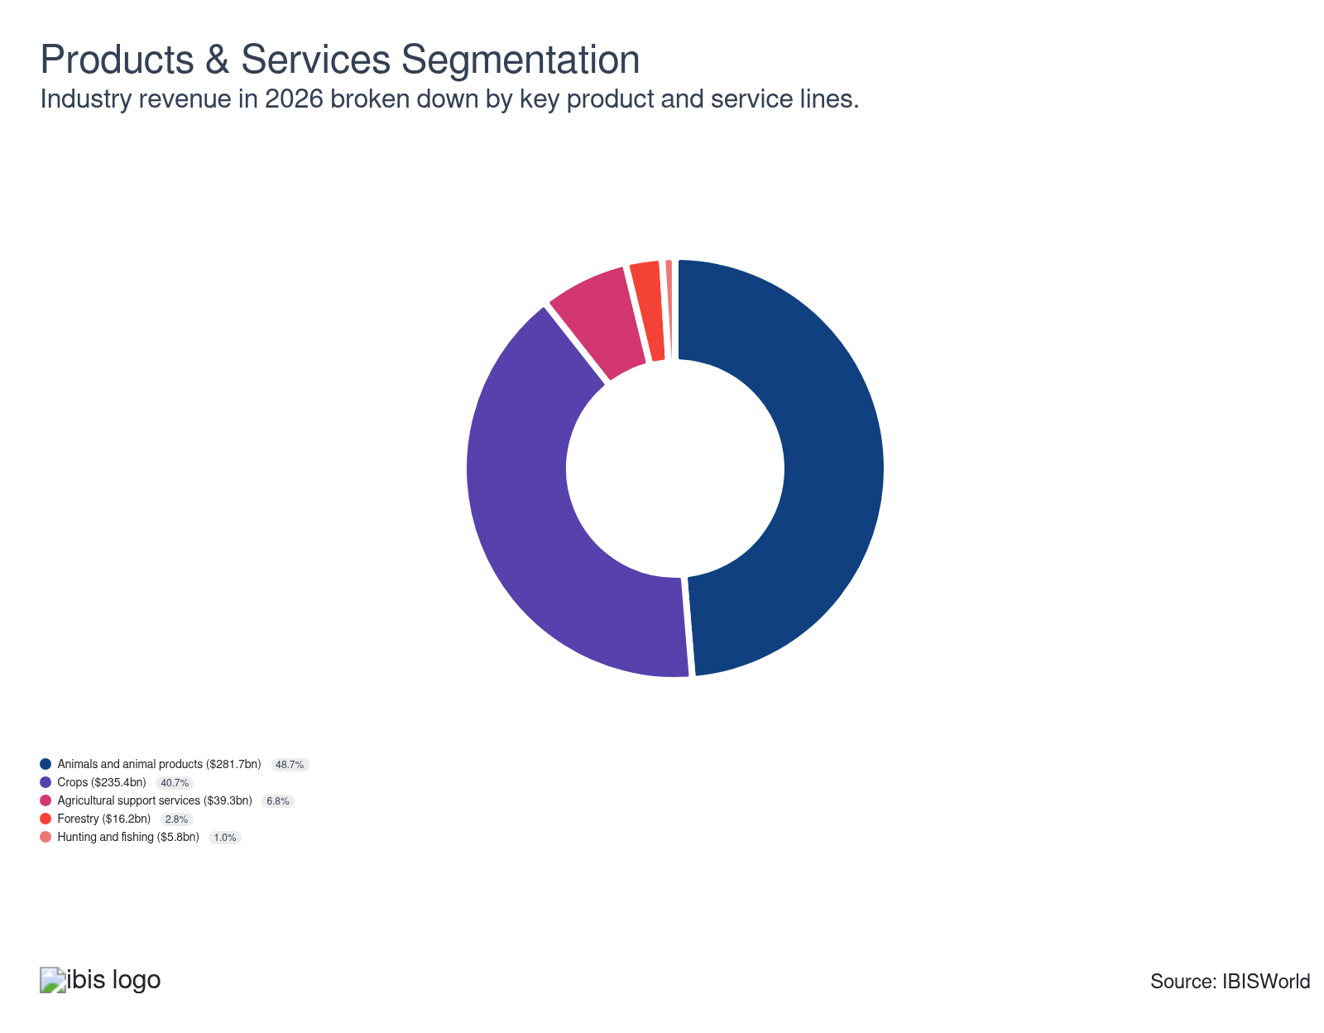

Major Players
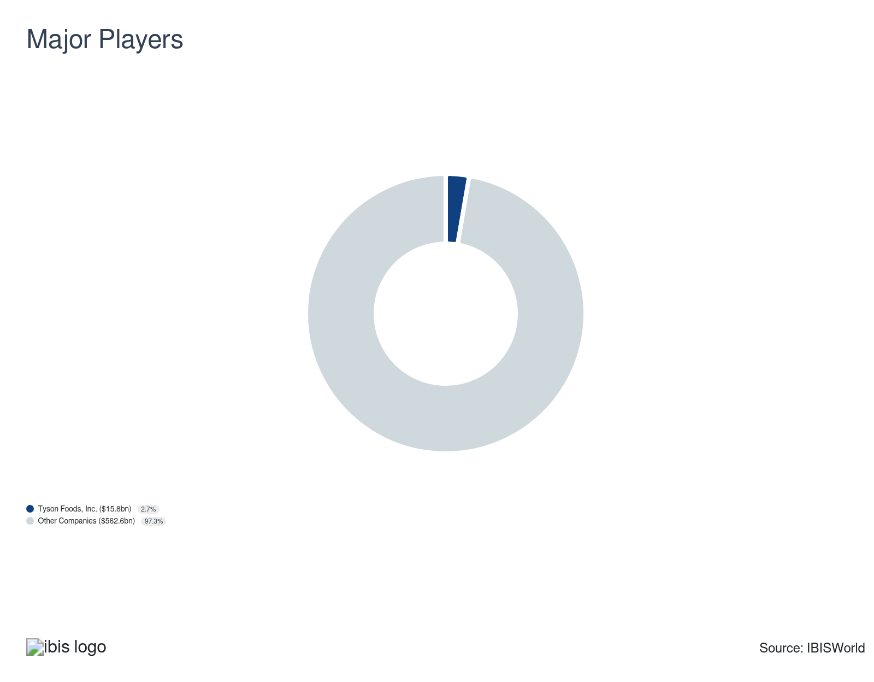

Key External Drivers
Key External Drivers | Impact
Agricultural price index | Positive
Producer Price Index: Feed | Positive
Price of fertilizer | Positive
Trade-weighted index | Negative
Population | Positive

Industry Structure
Characteristic | Level | Trend
Concentration | Low
Barriers To Entry | High | Increasing
Regulation and Policy | High | Steady
Life Cycle | Mature
Revenue Volatility | Moderate
Assistance | High | Steady
Competition | High | Steady
Innovation | Low

SWOT
Strengths  High Profit vs. Sector Average | Weaknesses  High Customer Class Concentration  High Product/Service Concentration  Low Revenue per Employee  High Capital Requirements | Opportunities  High Revenue Growth (2021-2026)  High Revenue Growth (2026-2031)  High Performance Drivers  Price of fertilizer | Threats  Producer Price Index: Feed

Executive Summary

Cornucopia of possibilities: Future agricultural price gains and steady yield improvements prime the industry for higher sales volumes and value
The US agricultural industry has been shaped by fluctuations in crop prices, production levels and yields in the current period. Prices for major crops such as corn, soybeans and wheat have stabilized from the highs observed in 2021 and 2022, bringing down crop farmer revenues with them. Record-high yields, particularly in corn, and rising soybean production offer a boon to some farmers, but excess global stocks have threatened overall incomes and international competitiveness. Costs of core inputs like fertilizer, seed, feed, and machinery now also account for an expanded share of farm income, and many are still on the rise. As a result, farmers are facing persistent cost pressures and depressed profit. Advancements in precision agriculture and regenerative practices are helping to offset some of these challenges by improving resource efficiency and productivity across large and mid-sized farms. Overall, revenue has dropped at a CAGR of 0.6% since 2021 to reach an estimated $578.4 billion after a decrease of 4.5% in 2026.
Alongside these price and production shifts, evolving consumer preferences are exerting a significant influence over the agricultural landscape. The demand for sustainably and ethically produced livestock products has grown, encouraging producers to adapt production practices, invest in traceability and pursue certification programs. Severe droughts across the western United States have led to prolonged cattle herd liquidations, driving short-term price gains and revenue increases but tightening long-term supply capacity. Meanwhile, climate change continues to introduce strong production fluctuations, as evidenced by altering pest and disease patterns and extreme weather events disrupting traditional farming cycles. Adaptation strategies, such as planting drought-resistant crops and investing in climate-smart technologies, are becoming increasingly common as farmers strive to maintain resilience.
Looking ahead, industry revenue is projected to transition from decline to steady growth, but profit pressures are likely to persist. Revenue is forecast to climb at a CAGR of 1.4% to reach $618.8 billion in 2031, supported by modest price appreciation, trend yield gains and a gradual upturn in export demand. Prices for core crops are set to inch higher through 2031, supporting firmer cash receipts. Yield gains driven by improved genetics, climate-smart practices and precision agriculture will also help to keep production trending upward, allowing output growth even where planted acreage plateaus or contracts. Emerging export opportunities in regions such as Africa and Southeast Asia, aided by a depreciating US dollar and ongoing trade missions, will partially offset competitive pressure from Brazil and a more constrained sales to China. At the same time, chronic labor shortages and rising wages will accelerate automation and robotics adoption, while carbon markets and nature-positive practices offer new but still nascent revenue streams that only a minority of producers are currently tapping.

3. Performance
https://my.ibisworld.com/us/en/industry/11/performance

Highlights
Revenue  $578.4bn  2021-26 CAGR ↓ 0.6 %  2026-31 CAGR ↑ 1.4 % | Employees  3m  2021-26 CAGR ↓ 1.8 %  2026-31 CAGR ↑ 0.6 % | Businesses  2m  2021-26 CAGR ↓ 2.0 %  2026-31 CAGR ↓ 0.2 %
Profit  $119.7bn  2021-26 CAGR ↓ 1.3 % | Profit Margin  20.7%  2021-26 CAGR ↓ 0.8 pp

Key Takeaways
- Crop prices have seen a significant downturn from their recent highs, which is straining revenue for farmers. While previous peaks temporarily buoyed income, the current market sees softened demand and ample global supplies depressing prices further.
- Climate change is creating significant threats to yearly yields and production. Farmers who can adapt by adopting precision agriculture techniques and resilient crop varieties will be better positioned to weather these challenges.
- US agricultural exports face ongoing threats from major competitors like Brazil as well as from China's push for self-reliance. However, emerging markets in Asia and Africa present valuable growth opportunities if navigated effectively.

Performance Snapshot
Revenue: | ↓ 2021-26 Revenue CAGR -0.6%
Revenue  $578.4bn  ’21-’26 ↓ 0.6 %  ’26-’31 ↑ 1.4 % | 2026 Revenue Growth  ↓ 4.5 % | Revenue Volatility  Moderate
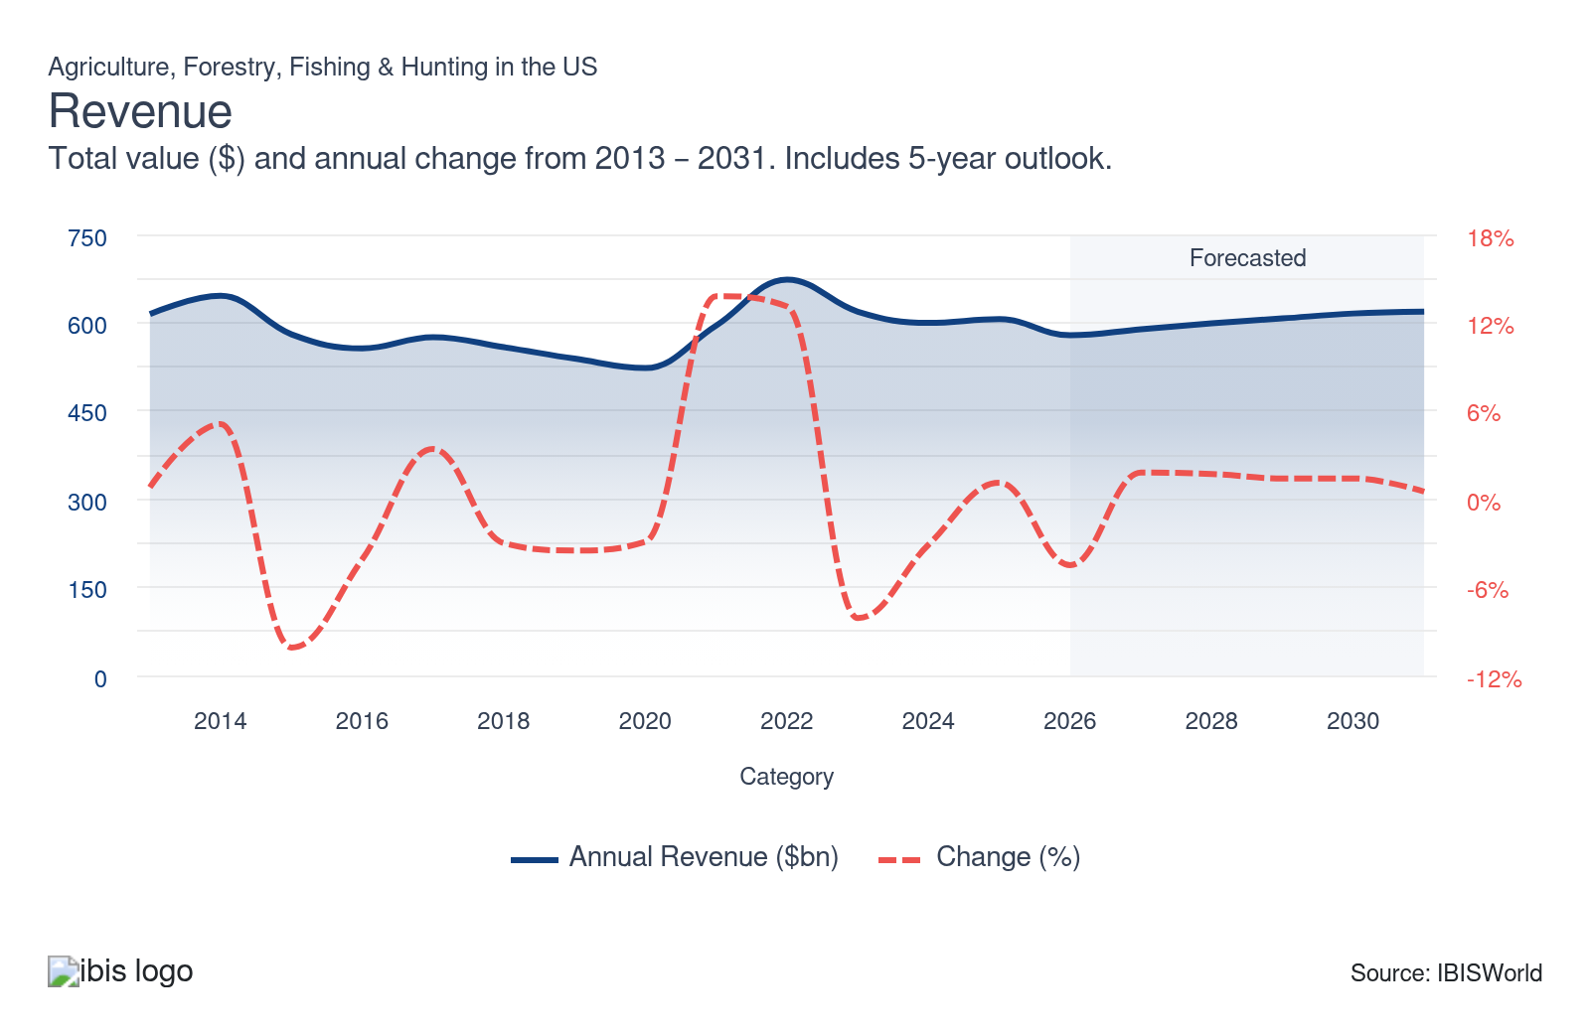
Employees: | ↓ 2021-26 Employees CAGR -1.8%
Employees  3m  ’21-’26 ↓ 1.8 %  ’26-’31 ↑ 0.6 % | Employees per Business  2  ’21-’26 ↑ 0.2 %  ’26-’31 ↑ 0.9 % | Revenue per Employee  $184k  ’21-’26 ↑ 1.3 %  ’26-’31 ↑ 0.7 %
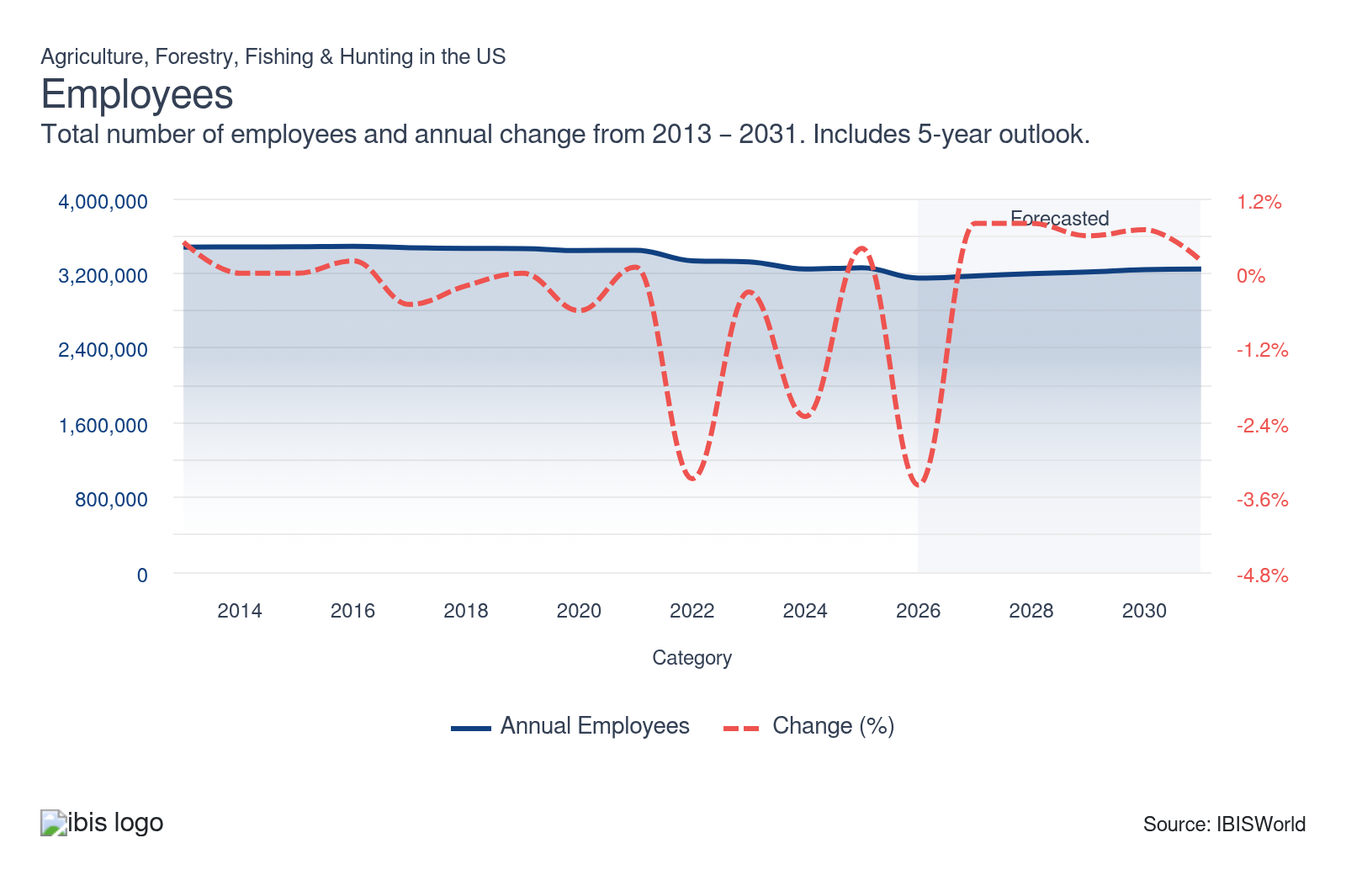
Businesses: | ↓ 2021-26 Business CAGR -2.0%
Businesses  2m  ’21-’26 ↓ 2.0 %  ’26-’31 ↓ 0.2 % | Employees per Business  2  ’21-’26 ↑ 0.2 %  ’26-’31 ↑ 0.9 % | Revenue per Business  $277.3k  ’21-’26 ↑ 1.4 %  ’26-’31 ↑ 1.6 %
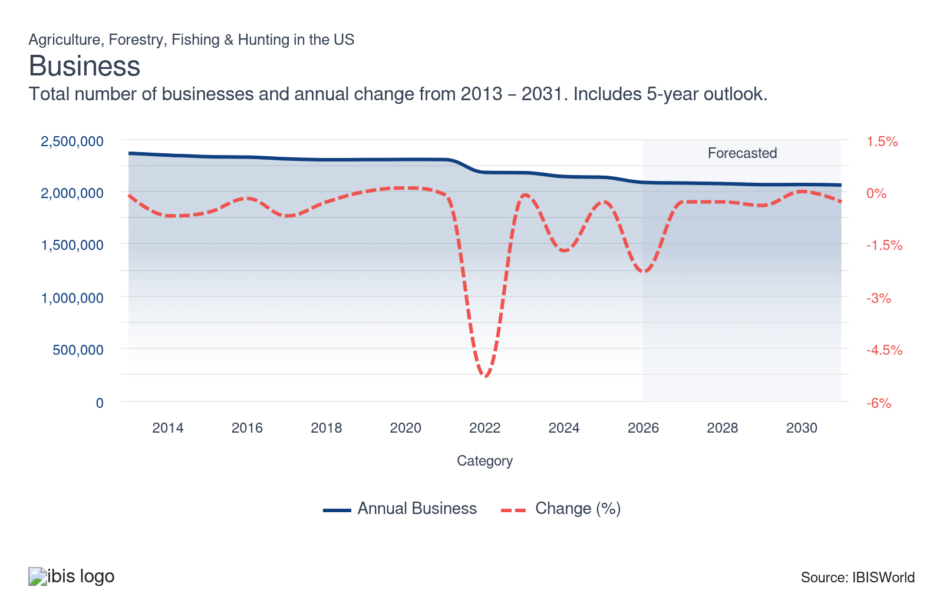
Profit: | ↓ 2021-26 Profit CAGR -1.3%
Total Profit  $119.7bn  ’21-’26 ↓ 1.3 % | Profit Margin  20.7%  ’21-’26 ↓ 0.8 pp | Profit per Business  $57,396
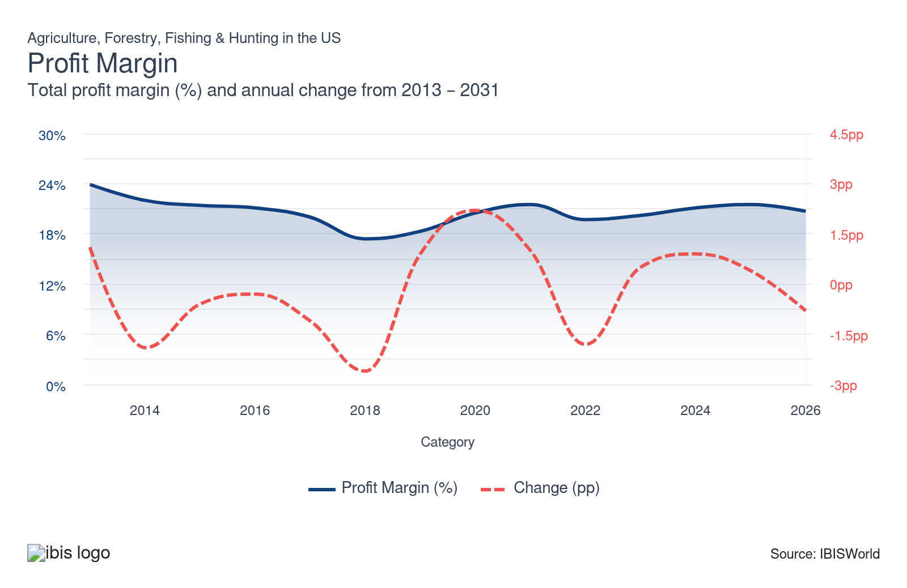
Current Performance
Current Performance

What's driving current industry performance?

Crop farmers' revenues ebb and flow with volatile prices
- USDA reports from 2025 and 2026 indicate that prices for core US crops have moderated from their 2021-2022 peaks but remain above historical averages. Crop yields and prices for products like corn, soybeans and wheat are showing mixed trends.
- The USDA projects a record-high corn yield for the 2025/26 season at 188.8 bushels per acre, with total production forecast at 17.0 billion bushels, driven by increased planted area and favorable conditions. Despite strong yields, prices are expected to soften, with the season-average corn price projected at $4.1 per bushel, down from previous years due to ample global supplies and higher ending stocks.
- Soybean production is forecast to be 2.6% lower than the previous season at 4.26 billion bushels, with an average yield of 53.0 bushels per acre. The season-average soybean price for 2025/26 is projected to be $10.20 per bushel, marking a modest 2.0% increase from 2024/25 but still reflecting global market competition and higher stocks.
- Wheat production is forecast at about 2.0 billion bushels for 2025/26, with a national average yield of 53.3 bushels per acre. Despite improved export prospects for Hard Red Winter wheat, overall prices are trending lower, with the season-average wheat price projected at $4.90 per bushel, down from recent highs of $6.96 in the 2023/24 season, as a result of growing stocks and despite increased total use.
- These price and yield trends are reshaping farm economics. All of these crop prices are down from previous highs, and while moderated prices are easing input costs for livestock producers and food manufacturers, they're squeezing crop farmers' profit. Despite lower prices compared to recent peaks, production costs remain elevated. The USDA estimates the cost to produce one acre of corn at $916 and soybeans at $678 in 2026; both are 3.0% higher than 2025 levels. This cost pressure is influencing planting decisions, with wheat acreage projected to decline in favor of more profitable crops like cotton and sorghum.
- Farmers are adapting to these market dynamics by adjusting crop rotations, investing in yield-enhancing technologies, and exploring value-added markets. The USDA and agricultural extension services are guiding farmers in risk management and market diversification to help them navigate this volatile environment.

Climate change has challenged the US agricultural industry's stability and demanded innovation
- Climate change has intensified extreme weather events, with droughts, floods and storms becoming more frequent and severe. The USDA Climate Hubs report that these changes are altering growing seasons, shifting pest and disease patterns, and impacting crop yields across the United States. As noted by the University of Georgia’s Extension Service, extreme weather events in 2024, for example, cost US farmers more than $20 billion in crop losses.
- Farmers are adopting various adaptation strategies to mitigate the impacts of climate change. These include planting drought-tolerant crops, adjusting planting dates, diversifying crop rotations and implementing water conservation techniques. Extension services, such as those from the University of California Cooperative Extension, are providing guidance on climate-smart agriculture practices tailored to specific regions. The USDA's Natural Resources Conservation Service (NRCS) reports that adaptation through changing planting dates and selecting better crop varieties could offset yield declines and even offer yield increases for some crops.
- While adjusting to new climate conditions is essential for maintaining production, the investments required to do so can be substantial. Farmers are already struggling to balance incomes with high input prices, and using specialized seeds, developing extensive irrigation systems and increasing fertilizer and pesticide use have only added on to purchase costs.
- Farmers can look to government subsidies and university research for support. Programs like EQIP are increasingly oriented toward helping farmers challenged by climate change. In December 2025, the USDA launched a $700 million Regenerative Pilot Program, with $400 million through EQIP and $300 million through CSP, to help farmers adopt whole-farm regenerative practices such as cover cropping, no-till and improved nutrient management. The program allows producers to bundle multiple regenerative practices into a single application, reducing administrative burden and signaling a growing federal focus on sustainable farming practices that enhance both adaptation and mitigation efforts.

The livestock industry is adapting to changing consumer preferences and market pressures amid drought-driven herd liquidation
- Severe drought across the western United States has led to significant cattle herd liquidations over the past few years. The USDA reports that droughts contribute to declining average herd sizes as intensity increases, with ranchers selling larger quantities of market and breeding stock. Severe drought conditions across the western United States have driven cattle inventories to their lowest level since 1951, with total US cattle and calves at 86.2 million head as of January 1, 2026, and the beef cow herd at 27.6 million head, the smallest since 1961. However, the rate of herd decline has slowed sharply, and modest increases in heifer retention suggest the industry may be approaching the end of the liquidation phase.
- Drought-induced liquidations have led to temporary increases in rancher revenues due to higher prices and sales volumes but also stressed long-term farm incomes. The Kansas City Federal Reserve found in 2023 that while drought has a short-term positive effect on rancher revenues, it negatively affects overall earnings.
- Consumer preferences for livestock products are also evolving, with increasing interest in the sustainability of production practices and the quality of life of animals.
- The interplay between drought, herd liquidation and changing consumer preferences is reshaping the livestock industry. While drought forces supply contractions, evolving consumer demand for sustainable, ethically produced meat pushes producers to adapt their practices, with more seeking organic, carbon-neutral, or grass-fed labels. This combination is likely to keep upward pressure on prices, with the 5-market fed steer price averaging $224.37/cwt in 2025, including a record $243/cwt in August, and the USDA projecting prices to rise further to $240/cwt in 2026, up 28.0% from 2024's $187.12/cwt average.
- Livestock producers have responded to high prices by increasingly marketing their stock rather than retaining or breeding them. Extension services such as the Texas A&M AgriLife Extension, University of Illinois Extension and Kansas State Research and Extension are actively advising producers on strategies to balance partial herd liquidation with feed purchasing decisions. These university-led programs provide critical, localized guidance on cost management, market timing and risk mitigation to help farmers maximize profit amid price volatility and changing input costs.

Precision agriculture revolutionizes farming practices, boosting efficiency and sustainability
- Precision agriculture technologies, including GPS-guided equipment, soil sensors and data analytics, have gained significant traction over the past five years. In an industry where high demand for expensive inputs such as seeds and agrochemicals can decimate a farm's profitability, increasing the efficiency of their use and expanding yields has been a boon to farmers. According to USDA data from 2024, autosteering systems on tractors and harvesters were used by 70.0% of large-scale crop farms and 52.0% of midsize farms in 2023, up from single-digit adoption rates in the early 2000s.
- A 2025 study from Michigan State University highlighted that close to 24.0% of farmed land is graded as low-yielding. These pieces of land are often treated the same as the rest, leading to overuse of fertilizers and pesticides and poor production. Using tech like soil sensors allows farmers to instead target specific areas of need and use precisely the amount of care and inputs needed, where they are needed.
- A study by Purdue University found that farmers perceive an average net benefit of almost $90 per acre from precision agriculture, with a benefit-cost ratio of 9.7 to 1. This suggests a much higher payoff than previous studies, attributed to whole-farm system benefits.
- As costs for core inputs continue to fluctuate, precision agriculture has allowed its adopters to strengthen their profit and reduce the damage that huge input commodity price swings can have. In May 2024, USDA and the University of Nebraska-Lincoln broke ground on the $160 million National Center for Resilient and Regenerative Precision Agriculture, the largest federal investment dedicated to precision agriculture research, aimed at advancing work on sustainable crop production, water management and climate-resilient farming practices. Farmers should continue to collaborate with university extension services to explore and learn more about precision agriculture practices or look to government grants to improve the efficiency of their equipment and processes.

What influences industry volatility?

Severe weather and natural disasters make crop yields unpredictable
- Droughts, floods, heatwaves, storms and wildfires directly damage crops and pasture, creating large year-to-year swings in yields and production volumes. As climate change increases both average temperatures and the variance of temperature and soil moisture, this raises interannual yield variance for major crops such as maize and soybeans. In practice, this means more frequent poor crop years where production falls sharply.
- Weather losses in one segment quickly spill over to others, amplifying volatility across agriculture. Crop failures, for example, reduce feed availability and drive up feed costs, putting strain on livestock and dairy farmers. Compared with many manufacturing and service industries, agriculture’s direct exposure to biophysical shocks makes its revenue more volatile over time.

Changes in consumer behavior affect demand for specific agricultural products
- Changes in consumer behavior alter demand growth across agricultural segments, creating winners and losers and adding to revenue volatility at the farm level. Rising interest in health, convenience and sustainability has boosted demand for items like fresh produce, specialty grains and plant-based proteins, while concerns about environmental footprints and animal welfare influence meat and dairy consumption patterns. These shifts tend to play out over several years but can quickly stress producers concentrated in slower-growing or declining categories.
- For producers, the main risk is misalignment between long-lived assets and evolving demand. Investments in specialized equipment, perennial crops or animal housing are expensive to repurpose if preferences move away from a given product, especially when those assets were designed around a narrow set of production practices or market specs. In many regions, biophysical constraints mean only certain crops or livestock systems are viable, so pivoting to a new product is not just costly but sometimes practically impossible. As opposed to more diversified consumer goods sectors, agricultural producers often have fewer flexible options for retooling in response to demand swings.

Government policies and regulations significantly impact agricultural revenue stability
- Farm revenue is tightly linked to government policy through subsidies, crop insurance, conservation incentives, trade measures and environmental regulations. Changes in farm bill programs, such as adjustments to crop insurance premium support, reference prices or disaster assistance, can materially alter producers’ downside protection and effective price floors, reshaping income volatility over the life of the bill. For example, recent adjustments that expanded crop insurance support for beginning farmers reduce revenue risk for that group but may leave others more exposed if other safety-net elements erode in real terms.
- At the same time, trade policy shifts and evolving environmental rules can change both market access and compliance costs. Tariffs or sanitary barriers can abruptly reduce exports and depress domestic prices, while stricter nutrient management or climate-related rules may increase operating costs but also unlock new revenue streams via conservation programs and climate-smart incentives.
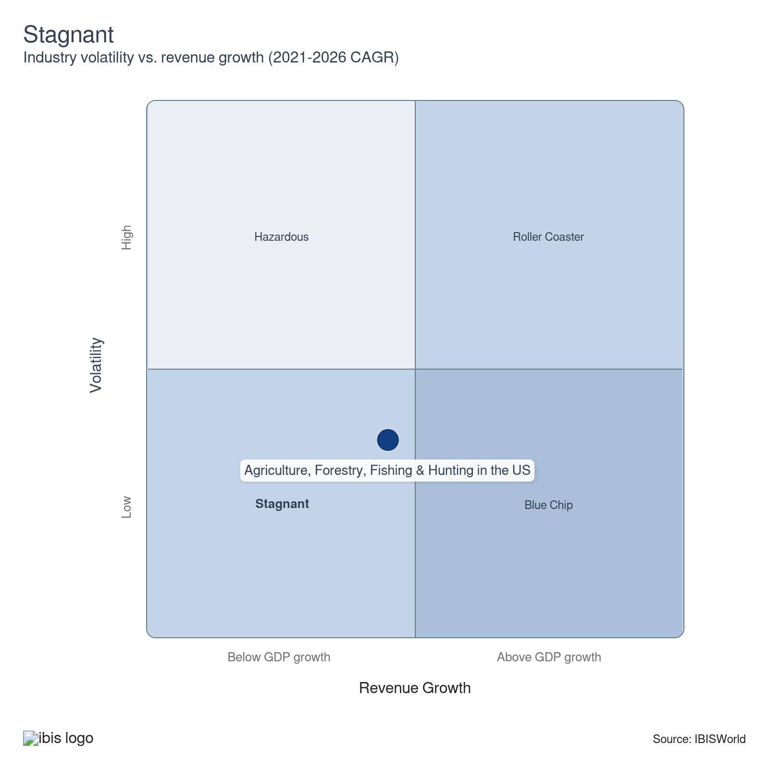

How do successful businesses overcome volatility?
Ability to alter goods and services produced in favor of market conditions
Farms that produce a variety of crops or animals are able to reduce the risk of financial loss if one crop has a poor season.
Plant premium, disease-resistant crops
While some consumers are opposed to genetically modified crops, genetically modified seeds can reduce volatility from crop disease outbreaks, while vaccinations can protect livestock.
Outlook | ↑ 2026-31 Revenue CAGR +1.4%

What's driving the industry outlook?

Crop yield and price gains will lift revenue, but may not fully offset profit pressures
- The USDA projects that crop prices will generally stabilize and rise modestly between 2026/27 and 2030/31. Corn prices are projected at $4.10 per bushel in 2026/27, edging up to $4.40 per bushel by 2030/31. World soybean prices are forecast to climb from $10.30 to $10.55 per bushel over the same period, while US wheat prices are set to rise from $5.40 per bushel in 2026/27 to $5.90 per bushel starting in 2030/31. Overall, the agricultural price index is forecast to climb 9.3% over the outlook period.
- Alongside moderate price gains, yields for most products are projected to increase due to technological advancements and improved farming practices. Corn production is expected to rise almost uninterrupted throughout the decade, with US corn planted acreage gradually declining but higher trend yields keeping production growth positive. Soybean production is projected to expand as well, supported by growing domestic demand for meal and oil and continued export growth, with the USDA expecting US soybean output to climb steadily over the projection period alongside rising world use.
- The combination of only modest crop price increases and continued high costs for inputs such as fertilizer could still squeeze farm profitability. This can lead to consolidation in the agricultural sector and drive the adoption of cost-saving techniques. While slight price appreciation offers some relief compared with earlier baseline assumptions, tight average sector profit is likely to persist for many producers. Consumers and food manufacturers will benefit from prices that remain below prior peaks, but farms may still need structural changes in operations to maintain profit.
- Farmers may need to reconsider their crop mix moving forward and lean more heavily on products with relatively stronger projected price or profit performance. However, this may not be possible for farmers in climates that support only a limited variety of crops, and regional competitiveness will continue to depend on yield potential, input costs and access to markets rather than price trends alone.

Climate change intensifies agricultural volatility and degrades soil health
- Climate change will continue to significantly impact crop yields in the coming years, with NASA studies indicating potential declines of 24.0% for maize and increases of 17.0% for wheat by 2030 under high greenhouse gas emission scenarios. A June 2025 study published in Nature found that global agricultural production declines the equivalent of 120 kcal per person per day for each 1°C rise in global mean surface temperature (GMST). Simultaneously, soil health is deteriorating due to increased temperatures and changing precipitation patterns, leading to reduced soil organic carbon and nitrogen across regions like the inland Northwest. Pest problems are also increasing as life cycles are extended by warm winters and breeding and hatching cycles are impacted.
- Wildfires, exacerbated by climate change, are becoming more frequent and severe in the United States. In 2025, 72,068 wildfires burned more than 5.0 million acres across the country, exceeding the 10-year average, with major events including the Los Angeles Palisades fires in January, widespread Oklahoma fires that destroyed over 500 structures in March and large California fires through the summer. As of February 20, 2026, the NIFC has already recorded 6,902 fires and 305,062 acres burned, compared to the 10-year year-to-date average of 3,504 fires and 71,556 acres, signaling another active fire year ahead.
- The increasing frequency and severity of wildfires are significantly impacting agricultural production and ecosystem health. Fires reduce sunlight for photosynthesis, damage soil quality and disrupt supply chains. The shift in forest composition due to changing fire patterns is altering habitats, with some areas transitioning from forests to shrublands or grasslands. These changes have far-reaching consequences for agriculture, biodiversity and rural economies.
- As these issues persist and, in many cases, worsen over the outlook period, farmers will need to ramp up their purchases of agrochemicals, utilities and resilient seed varieties, threatening profit. Agricultural services providers, including forestry services, will see increased demand for their offerings as farmers, timber tract operators and the Forest Service look to protect their lands from pests, fires and soil degradation and invest in precision agriculture for more efficient resource use.

Emerging markets provide opportunities for US farmers
- As agricultural prices stabilize and competition from developing crop and livestock sources such as Brazil intensifies, US agricultural exports face near-term headwinds. Total US agricultural exports across all stages of production – including processed foods, feeds and other value-added products beyond the farm gate – are projected at $173.0 billion in FY 2026, still below the 2022 record of $196.0 billion. However, the USDA's long-term projections show these broad agricultural exports recovering and growing at an average annual rate of 1.7% starting in 2027, reaching $208.3 billion by 2035. New growth opportunities, particularly in Asia, Africa and the Middle East, will be central to this rebound.
- Competition from low-cost exporters and trade instability with China remain persistent threats to the US's agricultural export share. Brazil shipped record volumes of soybeans globally in 2025 and is forecast to expand its reach in the coming years, supported by structurally lower production costs, a weak real and continually expanding acreage. Meanwhile, China, historically the largest destination for US soybean exports, imposed retaliatory tariffs on US soybeans in April 2025, causing shipments to plummet before a November 2025 trade deal committed China to purchasing 25 million metric tons annually through 2028, still below the five-year average. The nation has also sought to reduce US imports as it focuses on agricultural production and self-reliance. These dynamics have motivated export diversification, as reliance on any single market subject to recurring tariff escalation poses a meaningful risk to US farm revenue.
- The depreciation of the US dollar after 2026 will provide some support for US agricultural exports, making them more competitive in global markets. A weaker dollar can enhance the attractiveness of US agricultural products abroad. At the same time, tariff-related adjustments and moderating exchange rates are expected to narrow the US agricultural trade deficit starting in 2026, further supporting export competitiveness over the outlook period.
- Africa is emerging as a major market for agricultural trade and investment. The USDA Economic Research Service (ERS) projects continued population growth for the continent, expanding market size. Coupled with rapid urbanization and rising incomes, this is driving increased demand for a diverse range of food products, including consumer-oriented goods like beverages, prepared cereals, poultry meat and dairy products, as well as intermediate goods such as soy meal, vegetable oils and other feeds. ERS research also indicates that the African Continental Free Trade Area (AfCFTA), launched in 2021, has the potential to further expand these opportunities by promoting economic integration and intraregional trade. However, progress has been slow due to ongoing negotiations on tariffs, intellectual property and investment protocols.
- The USDA’s 2025/26 cotton and grain outlooks, along with recent export sales reports, highlight Southeast Asia’s growing importance for US agricultural exports. Vietnam continues to be a leading growth market for US cotton, with imports near record levels in 2024/25 and still strong in 2025/26. Corn exports to the region remain significant, as Vietnam’s livestock and aquaculture sectors drive rising feed grain demand. Thailand has emerged as another key opportunity market, with a 2025 USDA trade mission to Bangkok underscoring expanding openings for US meats, dairy, tree nuts, fresh fruit and food ingredients.
- While opportunities in traditional markets such as China may not be as plentiful as they once were in the coming years, agricultural producers who can build strong bonds in up-and-coming markets will be better able to withstand future export revenue declines.

Labor shortages and rising wages are reshaping the agricultural workforce and accelerating automation
- Chronic labor shortages remain one of the most pressing challenges for US agriculture. In 2025, the H-2A temporary agricultural worker program surpassed 400,000 positions requested for the first time in its history, with 398,258 positions ultimately certified, a 185.0% increase over the past decade. Foreign seasonal labor has become essential to labor-intensive crop production. The aging and retirement of undocumented farmworkers who arrived in the 1990s, combined with more aggressive immigration enforcement, is further tightening the available labor pool.
- Farm labor costs have risen sharply, with total agricultural labor expenditures forecast to exceed $53 billion in 2025. National crop farmworker wage increases have outpaced nonfarm wage growth in recent years. In October 2025, the Department of Labor finalized a new rule revising how H-2A wages are calculated and counting employer-provided housing as compensation, which the Department of Labor estimates will save farmers an average of $2.4 billion per year over the next decade, providing some relief.
- These labor dynamics are accelerating the adoption of agricultural robotics and automation. Autonomous vehicles, computer-vision weed detection and robotic harvesters are moving from the pilot stage to commercial deployment, with new offerings from John Deere and other major producers rolling out in the current period. Rather than fully replacing workers, many of these systems function as collaborative robots that handle repetitive monitoring and data collection while human workers focus on higher-skill tasks like crop inspection, equipment maintenance and decision-making.

Carbon markets and nature-positive farming are positioned to unlock new revenue streams for farmers
- Carbon credits represent the right to emit one metric ton of CO2 or equivalent greenhouse gases. Farmers can earn these credits by implementing practices that sequester carbon in soil or reduce emissions, such as no-till farming, cover cropping and improved nutrient management. Once verified, farmers can sell these credits to businesses looking to offset their emissions.
- Carbon markets offer farmers a new opportunity to generate income by implementing sustainable practices that sequester carbon. The USDA reports that farmers and ranchers can generate carbon credits by adopting practices to reduce emissions or sequester carbon on their land. These practices include no-till farming, cover cropping and agroforestry. As noted in South Dakota State University Extension's 2024 analysis of the role of carbon markets in agriculture, producers can increase earnings by selling carbon credits to large carbon emitters, helping diversify their revenue and build financial resilience. Participation has remained low up to this point, currently at just 3.0% of surveyed farmers, measured by the USDA, but SDSU's report notes that demand is growing.
- Nature-positive farming practices can not only generate carbon credits but also improve soil health, leading to better water retention, reduced erosion and increased fertility. These methods can result in long-term productivity gains and cost savings for farmers.
- The USDA is actively working to ensure farmers, ranchers, forest landowners and tribal communities have opportunities to participate in carbon markets. The department also releases assessments of current market activity, barriers to participation and opportunities to improve farmers' and forest landowners' access to carbon markets.
Life Cycle | Mature

Why is the industry mature?

Contribution to GDP
Despite the significant volatility seen by the agriculture industry over the current period, its contribution to the US GDP remained consistent, with established, mature market segments continuing to grow in line with the broader economy. Strong price increases for crops, livestock and essential industry services further drove the industry's expansion.

Market Saturation
The agriculture industry is highly saturated, with nearly total acceptance of its products globally. Most agricultural goods, such as grains, fruits and vegetables, are daily essentials. Growth opportunities are limited as the market is mature, and expansion typically depends on innovation or capturing market share from competitors rather than creating new demand.

Innovation
Innovation in agriculture primarily targets production efficiency and sustainability improvements rather than creating new product categories. Advancements in precision farming, crop genetics and sustainable practices are more common than novel food products. While organic and plant-based alternatives have gained traction, most innovation aims to optimize existing product lines and production methods, reflecting the industry's mature stage.

Consolidation
The agricultural landscape in the US is mainly comprised of small, independent farms, each typically limited to a single location. While some sub-industries contain large corporations, few businesses hold significant market share, maintaining a diverse and decentralized market.

Technology and Systems
The agriculture industry is leveraging advanced technologies to enhance operational efficiencies rather than developing new products. Connected systems, IoT devices, soil sensors, livestock tracking chips and more are enabling real-time data collection and analysis, allowing farmers to make more informed decisions. Genomic testing has also allowed farmers to better identify and proliferate prized crop and livestock traits.

4. Products and Markets
https://my.ibisworld.com/us/en/industry/11/products-and-markets
Largest Market  $281.7bn  Animals and animal products | Product Innovation  Low

Key Takeaways
- Demand for agricultural services grows as climate change necessitates pest protection and resource-efficient practices. Forestry services are seeing increased interest, especially with the growing threat of wildfires.
- Farm-to-farm sales are crucial for the sector's stability. Farms rely on each other for essential inputs such as seeds. However, major seed companies and machinery manufacturers often embed contractual restrictions or exclusive licensing requirements into their sales terms, which can restrict farmers’ ability to share or resell patented seeds, reducing the flexibility and autonomy that farm-to-farm exchanges once provided.
- The livestock sector is seeing strong prices amid shifting consumption trends and drought-induced supply constraints. Consumer health concerns and climate conditions are driving changes in meat production and marketing.

Products and Services
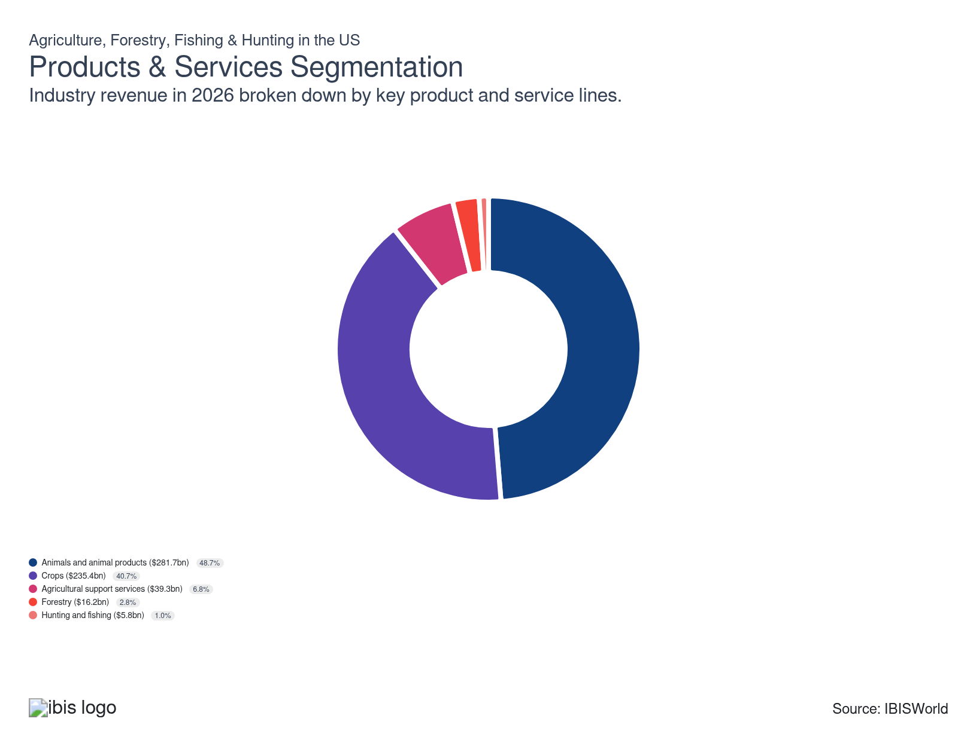

How are the industry’s products and services performing?

Livestock and animal products are the fastest-growing revenue segment, driven by record cattle prices
- The emergence of plant-based alternatives and health concerns has prompted many to eat less meat in recent years, particularly red meats like beef. The inflation of food prices has also pushed customers to select lower-cost meat options, such as choosing chicken over premium beef cuts for their protein source.
- Despite a slight decline in per capita meat consumption, meat prices have increased due to increased international demand and short livestock supplies, creating significant revenue gains for famers. Persistent drought conditions have discouraged herd rebuilding and led many farmers to prioritize marketing their livestock rather than retaining them for herd rebuilding.

Crop production faces a complex outlook due to weather extremes and market uncertainties
- Crop production, encompassing grains, oilseeds, cotton, fruits, vegetables, nuts and other field crops, generates the largest share of sector revenue. The USDA reports total crop cash receipts of $238.1 billion in calendar year 2025, their lowest level since 2020, with corn and soybeans alone accounting for $106.1 billion, or 44.6% of the total. Receipts are forecast to increase modestly to $240.8 billion in 2026.
- Despite softening prices, production volumes are at historic highs. The 2025 corn crop reached a record 17.0 billion bushels at a record yield of 186.5 bushels per acre, while soybean yields also hit an all-time high of 53.0 bushels per acre. These gains reflect continued adoption of improved seed genetics, precision agriculture and favorable growing conditions, but ample global supplies and elevated ending stocks are capping price recovery and compressing crop-segment profit.

Climate change has created new opportunities for agricultural services providers
- The increasing occurrence of extreme weather events and seasons has created expanded demand for agricultural support services. The EPA's 2025 report on the impacts of climate change on agriculture notes that warm winters have created an increased need for pest protection while droughts and floods threaten yields.
- The Forest Service, a significant customer of forestry services, has undergone major budget restructuring for FY 2026. Instead of increasing its own budget, the Forest Service requests $2.3 billion in discretionary appropriations for core programs, reflecting a substantial decrease from FY 2025 and the elimination of several initiatives. In a pivotal change, wildfire risk management funding, including most firefighting operations, is now transferred to the newly created US Wildland Fire Service under the Department of the Interior, which requests $6.55 billion for FY 2026 to address wildfire suppression, firefighter pay and expanded wildfire response capacity.
- This transition reflects intensifying federal efforts to combat rampant forest fires across many areas of the US, while the Forest Service’s own budget priorities for FY 2026 are now focused on conservation, infrastructure and climate change adaptation outside firefighting.

The forestry industry sees renewed demand amid interest rate cuts and sustainable practices
- This segment includes businesses that grow and harvest timber on long rotations, supplying logs, pulpwood and other forest products for construction, packaging and industrial uses. The US forestry and logging sector tracks closely with construction and manufacturing cycles. The construction rebound earlier in the current period has faded, but lower interest rates and a persistent housing shortage are preventing a deeper downturn. Total US housing starts in 2025 were essentially flat year over year at 1.36 million units, as reported by the New York Times, with single-family starts down, keeping lumber demand subdued but broadly stable.
- Lumber prices have remained volatile in the current period but have stabilized in more recent years. As of the latest available pricing index reporting from the BLS in October 2025, lumber prices were up only 0.4% year over year.
- Concerns around the environmental impacts of logging have motivated major players like Weyerhaeuser to create sustainability plans, aiming to protect the biodiversity and ecosystems of their managed lands. They are also collaborating with The Nature Conservancy on a multiyear project to advance climate-smart forestry and research forest carbon sequestration.

Consumer preferences propel fish sales but challenge hunting and trapping
- This segment includes sales of seafood, trapped and hunted animals and animal products. It also includes businesses that operate hunting and fishing preserves.
- Fish sales have benefited in recent years from health concerns over red meat and positive perceptions around fish consumption. However, high input and energy costs have challenged fishery profit, and these producers have struggled to pass costs on to customers who are quick to substitute other proteins when seafood products become too expensive.
- Negative perceptions around hunting and trapping have hurt demand for goods from commercial trappers. Meanwhile, the decreasing availability of public hunting land and increasing leisure time have helped maintain sales of private fishing and hunting preserve services.

What are innovations in industry products and services?

Robotics, sensing and biotech help to reshape modern production
- Agriculture, forestry, fishing and hunting industries are integrating advanced robotics, autonomous machinery and sensor-based field systems to make operations more precise, resilient and environmentally conscious. Precision agriculture technologies – such as GPS-guided equipment, variable-rate applicators, in-field sensors and robotic platforms – are increasingly common on larger farms and in high-value specialty crops, even though adoption remains uneven across smaller operations and commodities.
- Producers are steadily expanding their use of drones, smart application tools and remote monitoring to respond to variable weather and optimize input use. In practice, this includes drone-based crop scouting and mapping, soil-moisture and canopy sensors tied to irrigation controls and targeted fertilizer and pesticide applications, which together can improve water-use efficiency and reduce nutrient losses, supporting soil and water stewardship goals.
- Forestry companies are retrofitting harvesting and silviculture equipment with advanced sensing, LiDAR and geospatial technology to support precision forestry. Data at the tree or sub-stand level enables more selective harvesting, improved planning for thinning and regeneration and better alignment with conservation, biodiversity and climate-related certification standards.
- Smaller operations often struggle to secure the capital and technical capacity needed to implement advanced digital management and traceability tools. High equipment and software costs, ongoing maintenance, connectivity gaps and limited training mean many small and diverse-owned farms and fisheries lag larger peers, making access to specialized financing programs, public cost-share and technical assistance critical for broad-based technology adoption and sector-wide sustainability gains.

Genetics and regenerative approaches drive climate-resilience
- Breakthroughs in genetics, including advanced crop breeding and gene editing, are enabling producers to develop plant and animal varieties with greater resilience to drought, pests and disease, resulting in more reliable yields and improved food quality. Regenerative agriculture, centered on practices like biological soil amendments, diverse crop rotations and carbon-focused land management, is gaining momentum as producers seek to improve soil fertility, enhance biodiversity and reduce the sector’s environmental impact.
- These innovations are fostering a shift toward adaptive and climate-resilient farming systems, aligning with growing regulatory expectations and consumer preferences for sustainable, traceable products. The up-front investment and technical learning curve for both genetics and regenerative methods can be challenging for producers without targeted support, making extension services and incentive programs crucial for widespread transformation.

What products or services do successful businesses offer?
Produce goods that the market currently favors
Many farms will rotate crops and will specialize in a variety of agricultural products. This reduces annual volatility and can help avoid revenue declines brought on by changing consumer preferences.
Offer a competitively priced product
As produce and livestock prices shift, farms must adjust their own prices to keep a steady stream of demand despite shifting market conditions.

Major Markets
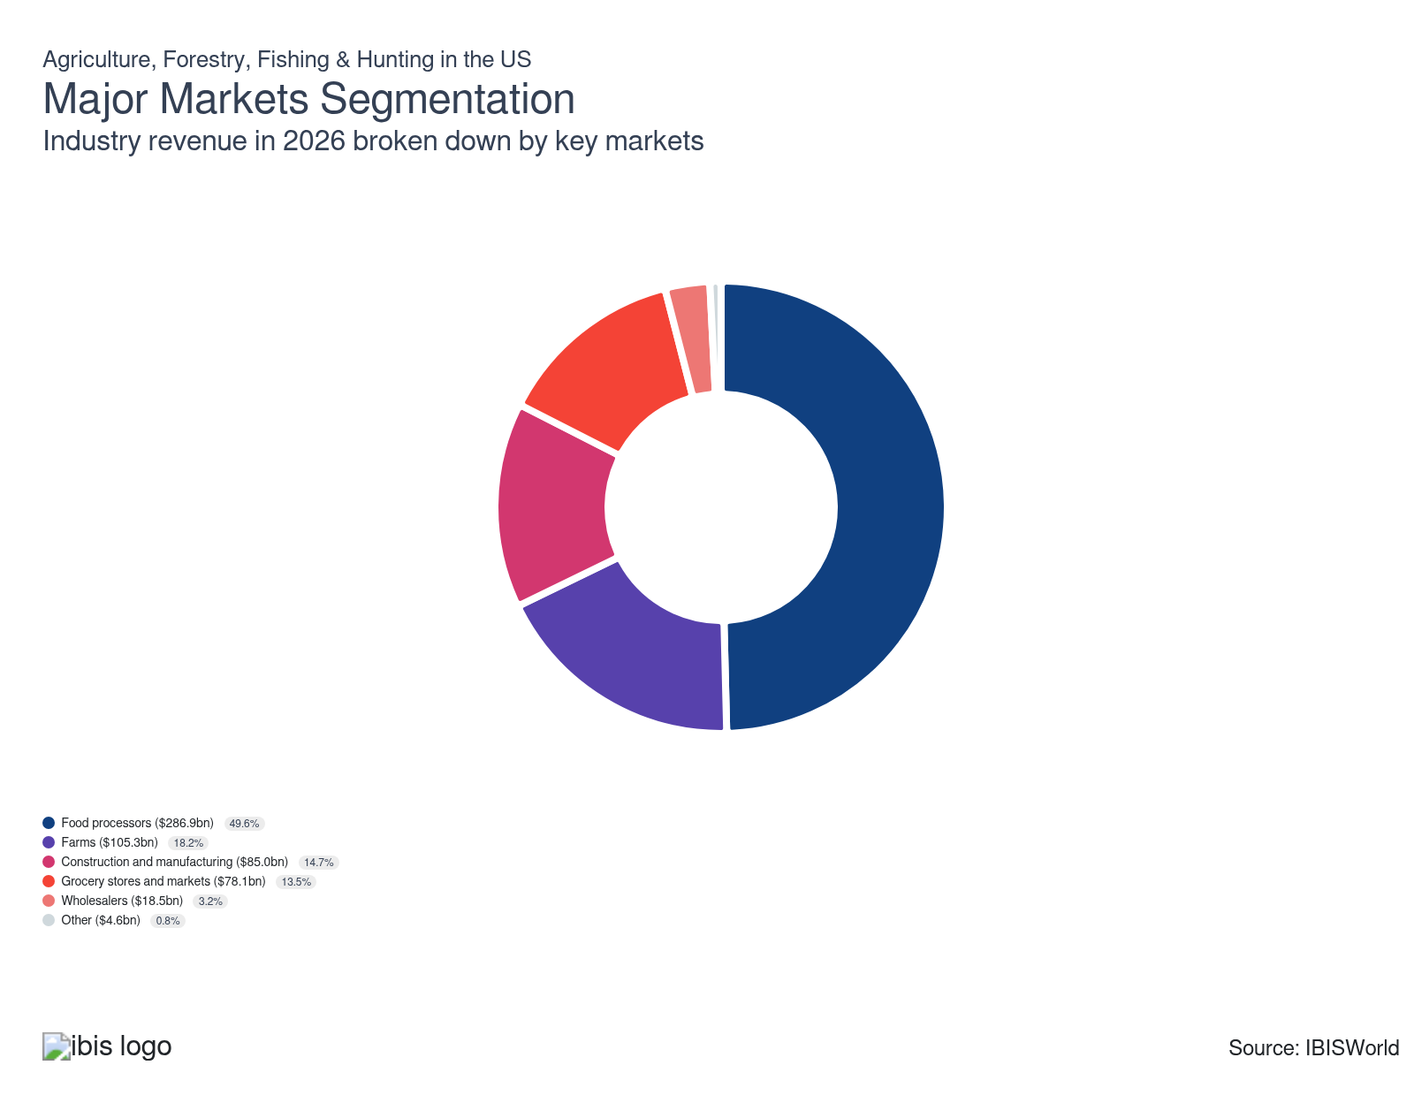

What’s influencing demand from the industry’s markets?

Food processors face pressure to innovate healthier products while managing volatile input costs
- Food processors, including major players like Tyson Foods and General Mills, are adapting to changing consumer preferences for healthier and more sustainable food options. Expanding offerings in high-value substitutes such as certified organic foods, gluten and lactose-free options and other niches has allowed processors to grow revenue and establish new markets, even as some premium categories face pushback from cost-conscious consumers in a high-inflation environment.
- Volatile commodity prices are impacting processors' margins, with the USDA's Food Price Outlook forecasting continued fluctuations in agricultural input and wholesale food costs throughout 2025 and into 2026. Passing these costs onto consumers has allowed processors to grow revenue and protect against larger profit declines but made it difficult to compete, particularly in the international market where lower-cost producers and private-label offerings intensify pricing pressure.
- Food processors' revenues have benefited from growing consumer spending and disposable incomes that allow consumers to spend more on processed foods and opt for upgraded food alternatives. However, with food-at-home inflation expected to slow in 2025 and 2026, volume growth and mix upgrades are becoming more important than simple price hikes as drivers of topline expansion.
- This market segment also includes manufacturers of animal feeds, which have performed strongly throughout the current period, buoyed by a healthy livestock sector and high pet care and nutrition spending. Declines in feed and fertilizer costs since their 2022 peaks have eased some input pressure for feed manufacturers, but uncertainty around herd rebuilding, disease risks and export demand keeps revenue growth uneven across species and product lines.

Farm demand for agricultural inputs fluctuates with commodity prices and weather patterns
- Farms, including crop and livestock producers, represent a significant market for seeds, feed and other agricultural inputs. Input suppliers closely track farm balance sheets and credit conditions, as changes in profitability quickly translate into shifts in seed, chemical, fertilizer and machinery spending.
- The USDA projects that, as of early 2026, net farm income will edge down slightly to $153.4 billion dollars in 2026, even as net cash farm income inches up, with much of the sector’s earnings still relying on elevated direct government payments and supplemental disaster assistance rather than stronger commodity markets or higher sales volumes.
- Drought conditions persisted in 2025, affecting 27.7% of the United States as of the US Drought Monitor’s August 26, 2025 update, with severe impacts in parts of the Northwest, Rockies, Northeast and southern Plains. These climate pressures drive strong demand for drought-resistant seeds, crop protection services and water-efficient irrigation solutions across major agricultural regions, as producers prioritize resilience in the face of more frequent and intense dry spells.
- Looking ahead to 2026, seasonal outlooks from NOAA’s Climate Prediction Center point to drought persistence or redevelopment across much of the Central Rockies, Southwest, Southern Great Plains and parts of the Southeast and Mid-Atlantic, suggesting that elevated demand for water-saving technologies, climate-resilient genetics and soil-moisture management tools is likely to remain a central feature of farm input markets in the near term.

Demand from industrial markets is on the rise due to biofuel mandates and sustainability initiatives
- The Renewable Fuel Standard (RFS) continues to drive ethanol and other renewable fuel production. The EPA's finalized total renewable fuel volume requirement is set at 22.33 billion gallons for 2025, up from 20.94 billion gallons in 2023 and 21.54 billion gallons in 2024, an increase of about 8% over 2022 levels. The EPA has also proposed required volumes for 2026 and 2027 of 24.02 and 24.46 billion gallons, respectively.
- Sustainability initiatives in apparel and packaging industries are boosting demand for natural fibers and biodegradable materials derived from agricultural sources. Companies are piloting more recyclable and compostable packaging, as well as fiber blends that reduce reliance on fossil-fuel-derived materials, which supports demand for cotton, hemp, wood pulp and other plant-based inputs.

Grocery stores and markets increase focus on local and organic produce to meet consumer demand
- While inflation and supply chain volatility have challenged supermarket profit, steady increases in food-at-home prices, as measured by the USDA's Economic Research Service (ERS), have kept overall revenues strong, even as the pace of grocery inflation moderates toward historical averages in 2025 and 2026. Grocers are now balancing price-sensitive shoppers with continued interest in premium offerings, private labels and value packs.
- Increasing disposable income has expanded consumers' demand for organic and premium meats, fruits and vegetables, which has, in turn, boosted demand for these products from this market segment. Retailers are responding by expanding shelf space for local, organic and sustainably branded items, while also negotiating harder on procurement costs and seeking year-round supply reliability from producers.
- The rise of online grocery shopping is also reshaping competition in the sector, with traditional brick-and-mortar stores facing pressure to develop robust e-commerce capabilities or risk losing market share to digital-first competitors. Industry farmers and ranchers will need to solidify relationships with grocers who can provide personalized online shopping experiences to benefit from this growing segment.

Wholesalers adapt to e-commerce trends and changing supply chain dynamics
- Large grain wholesaling companies include Cargill, Scoular, Tronson Grain and Pacificor, while major livestock wholesaling companies include Smith Farms, East Carolina Stockyard and South Texas Cattle Marketing. Many large wholesalers are vertically integrated and operate in processing and retailing as well as wholesale.
- Wholesalers in this market segment make it easy for downstream customers to source agricultural products without having to establish relationships with a wide array of small farmers, an important function in such a fragmented industry. The threat of wholesaler bypass has been exaggerated by the rise of digital platforms and communications that make it easier for farms and farm co-ops to connect directly with retailers, threatening wholesalers' position in the agricultural supply chain.

Other niche markets show varied growth patterns influenced by industry-specific trends
- This segment includes diverse markets such as horse owners, tobacco processors and agricultural brokers.
- Despite its estimates suggesting the US horse population has declined from prior peaks, the American Horse Council’s latest national economic impact work indicates the industry is still expanding in economic terms. Spending per horse, and on related services and events, has increased and continues to positively impact revenues for horse producers and service providers.
- Cigarette sales in the US have continued to decline. In 2024, total sales dropped another 9.2% year-over-year, reaching 6.9 billion packs sold nationally as reported by the CDC foundation. This pattern is reinforced by persistently high state and federal taxes, now averaging $1.97 per pack at the state level and $1.01 federally, as well as the growing popularity of vaping, nicotine pouches and other alternative products. The steep decline in sales has further reduced revenues for US tobacco farmers.

International Trade
Total Imports  $80.4bn  ’21-’26 ↓ 2.3 %  ’26-’31 ↑ 1.3 % | Total Exports  $78.6bn  ’21-’26 ↓ 6.5 %  ’26-’31 ↑ 1.4 % | Trade Balance  Net Importer  ↓ Deficit: $-1.8bn

International Trade Imports
International Trade Imports
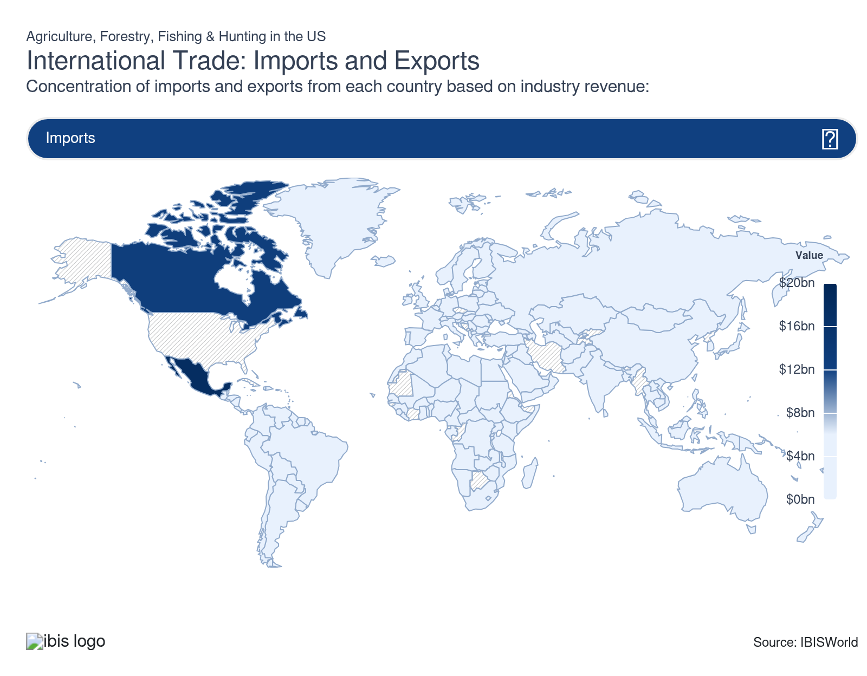
International Trade Exports
International Trade Exports
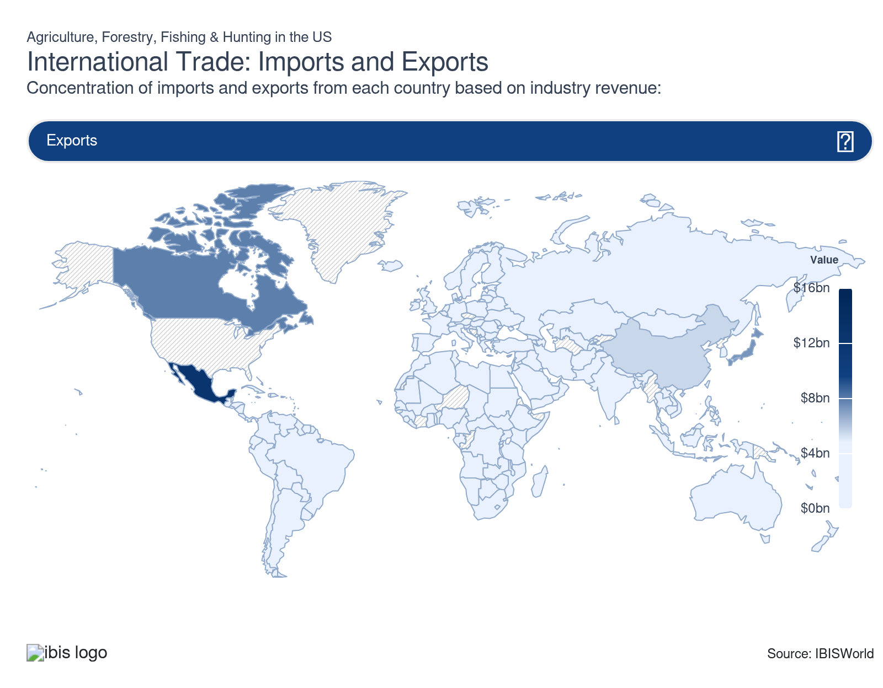

Imports
Moderate | Decreasing

What are the industry’s import trends?

Strong demand for specialty foods is reshaping the US's import mix
- US demand for fruits, vegetables and specialty foods has shifted from seasonal to year-round, with imports filling an increasing portion of this gap. Retailers and foodservice operators now routinely source berries, avocados, peppers, asparagus and salad vegetables from Mexico, Central America and South America to meet expectations for constant availability and quality. Rising interest in health-conscious and global cuisines is also pulling in more nuts, tropical fruit, coffee, cocoa and specialty processed foods, pushing horticultural imports to record or near-record values.
- Domestic production has grown, but it can’t fully match desired volumes, varieties and timing, especially for labor-intensive or climate-sensitive crops. Trade data show fresh and processed horticultural products are one of the fastest-growing import categories, even in years when overall ag trade is weak, with Mexico, Canada, the EU and Latin America dominating supply. This structural dependence is only deepening as consumers stick with premium produce and specialty items despite slower overall food inflation.

Record-high imports deepen a structural US agricultural trade deficit
- Over the past five years, US agricultural imports have climbed faster than exports, pushing the trade balance firmly into deficit. The USDA’s latest trade outlook projects imports holding near record levels in 2025 before easing only slightly in 2026, driven by strong demand for horticultural goods, tropical products, sugar, beverages and processed foods. Even when global prices soften, Americans’ taste for imported food keeps dollar values high.
- At the same time, export growth has stalled under the weight of weaker prices, a strong dollar and tariff-driven market losses in countries like China, leaving the US more reliant on domestic demand to absorb surplus production. The result is a widening and now persistent agricultural trade deficit.
- For US producers and processors, a chronic trade deficit signals tougher competition at home. Imported products increasingly share the same shelf space and processing capacity as domestic goods, pressuring profit and forcing farms, packers and brands to compete on quality, reliability, sustainability and differentiation rather than price alone.

Exports
Moderate | Decreasing

What are the industry’s export trends?

US agricultural exports face challenges in 2026, struggling to recover from a downward trend
- Agricultural exports are projected to decline in 2026, continuing a drop that began after 2022. This decline is attributable to factors such as reduced demand from key markets, strong international competition and lower unit values for major commodities.
- Export performance varies by commodity and region. Bulk commodities like soybeans and some feed grains have seen the steepest value declines to China and other tariff-affected markets, even as 2025/26 season corn export volumes hit record levels into alternative destinations, helped by competitive prices and strong global feed demand. In contrast, beef and dairy exports have held up comparatively better in markets such as Mexico, Canada, Japan and South Korea, where trade agreements and strong consumer demand continue to support volumes despite currency and policy headwinds.
- The continuing export slowdown poses significant challenges for US agricultural producers and agribusinesses that are heavily reliant on foreign markets. Loss of market share among traditional buyers is unlikely to be fully reversed quickly, forcing exporters to deepen their presence in emerging growth regions, particularly in parts of Southeast Asia, the Middle East and Africa, and to emphasize traceability, sustainability and value-added attributes to differentiate US products in a more contested global market.

China and Brazil pursue agricultural self-reliance, reshaping global trade dynamics
- Over the current period, China has intensified its focus on agricultural independence, with President Xi Jinping declaring food security a top national priority. In 2024, China unveiled its latest set of policy guidelines for agricultural development, setting a goal to become an agricultural power and emphasizing rural growth and domestic food security. Similarly, Brazil has been increasing its agricultural productivity and expanding its global market presence by rapidly extending its supplies of core crops and acreage of agricultural land, as noted in the USDA's analysis of Brazil's growth.
- These efforts by China and Brazil are significantly impacting global agricultural trade patterns. China's push for self-sufficiency, particularly in key crops like soybeans, is reducing its reliance on US imports. Meanwhile, Brazil's increased production and export capacity are filling the gap in global markets, leading to increased global stocks of many agricultural products and decreasing the US's market share and the value of US goods.

5. Geographic Breakdown
https://my.ibisworld.com/us/en/industry/11/geographic-breakdown

Key Takeaways
- The Midwest and Great Plains remain crucial for US crop production, leveraging fertile soils and strong infrastructure. Challenges include supply chain sensitivity and adapting to climate impacts to sustain dominance.
- The West and Southwest excel in diverse production despite drought pressures, with California leading in fruits and nuts. Water scarcity is reshaping agricultural practices here, prompting efficient irrigation investments.

Business Locations
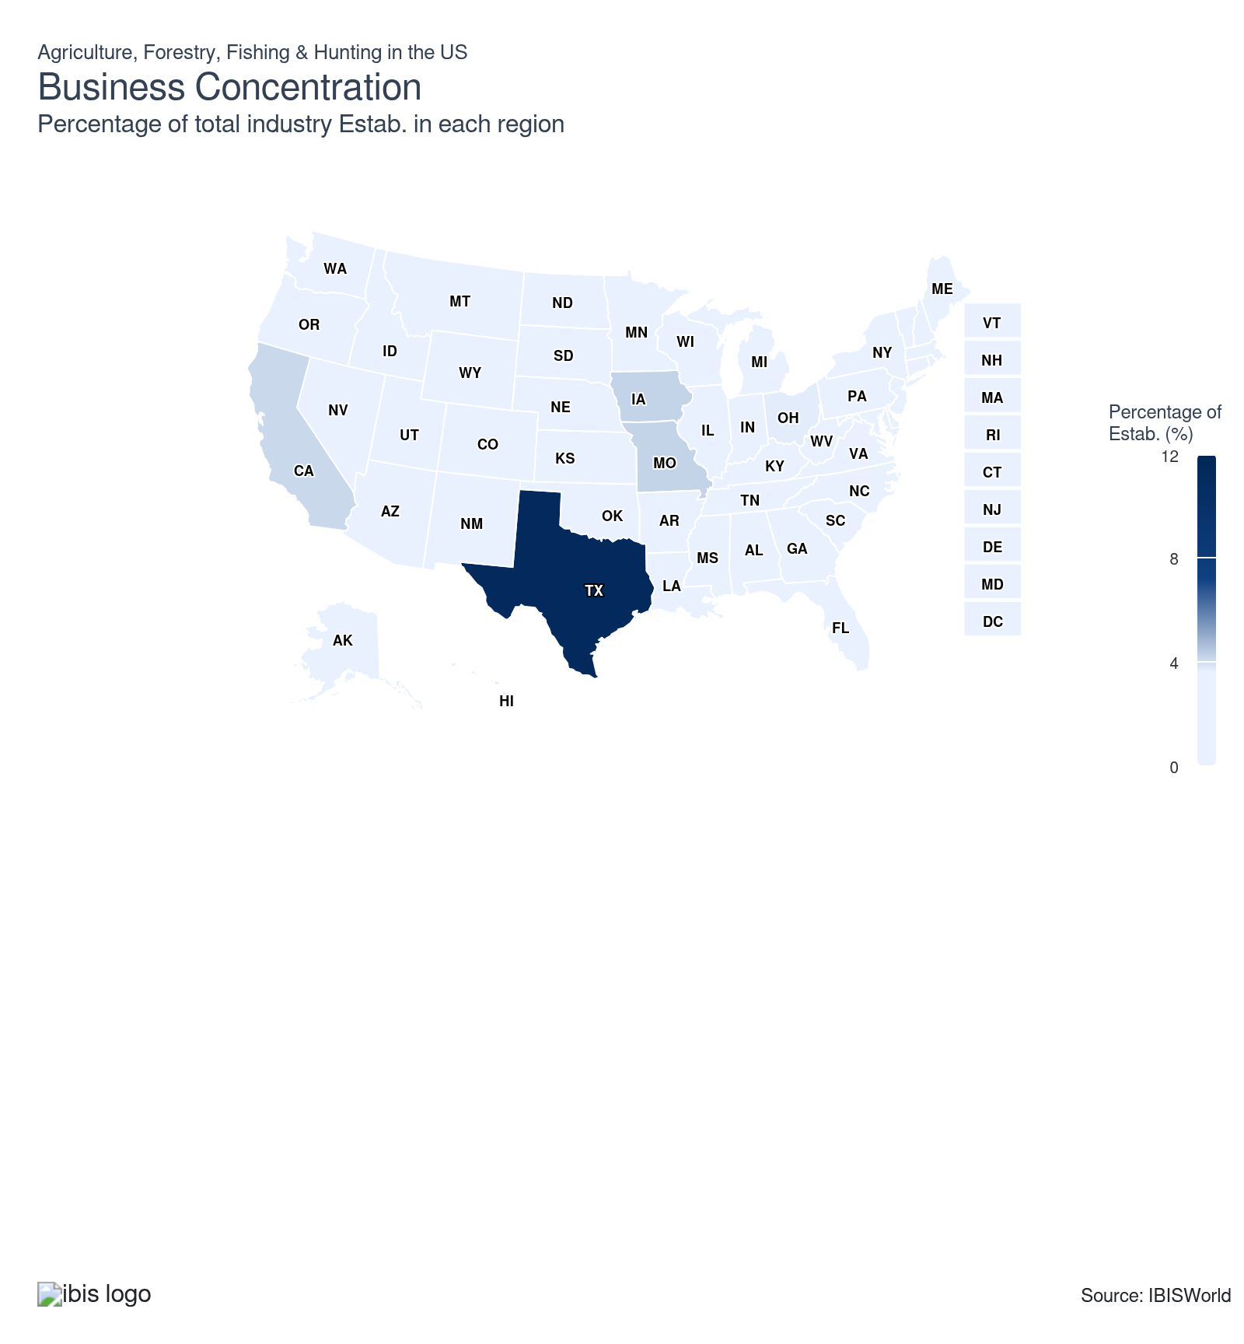
State | Estab.  Units | Estab.  % | Population  %
Texas | 233731 | 11.2 | 9.4
Iowa | 87579 | 4.2 | 0.9
Missouri | 87618 | 4.2 | 1.8
California | 85048 | 4.1 | 11.5
Ohio | 76347 | 3.7 | 3.5
Illinois | 71482 | 3.4 | 3.7
Kentucky | 69180 | 3.3 | 1.3
Minnesota | 69397 | 3.3 | 1.7
Oklahoma | 69479 | 3.3 | 1.2
Tennessee | 62875 | 3.0 | 2.1
Wisconsin | 61975 | 3.0 | 1.7
Florida | 57370 | 2.7 | 7.0
Kansas | 55414 | 2.7 | 0.9
Indiana | 54703 | 2.6 | 2.0
Pennsylvania | 53710 | 2.6 | 3.8
Michigan | 51077 | 2.4 | 3.0
North Carolina | 50435 | 2.4 | 3.3
Oregon | 49825 | 2.4 | 1.2
Georgia | 48699 | 2.3 | 3.3
Alabama | 44780 | 2.1 | 1.5
Nebraska | 44914 | 2.2 | 0.6
Washington | 46664 | 2.2 | 2.3
Arkansas | 43523 | 2.1 | 0.9
Virginia | 44741 | 2.1 | 2.6
Colorado | 38504 | 1.8 | 1.8
Mississippi | 37173 | 1.8 | 0.9
New York | 36209 | 1.7 | 5.8
Louisiana | 30056 | 1.4 | 1.3
South Dakota | 28818 | 1.4 | 0.3
Idaho | 27906 | 1.3 | 0.6
Montana | 27258 | 1.3 | 0.3
South Carolina | 28084 | 1.3 | 1.6
North Dakota | 25240 | 1.2 | 0.2
West Virginia | 24307 | 1.2 | 0.5
New Mexico | 21356 | 1.0 | 0.6
Arizona | 18481 | 0.9 | 2.2
Maine | 18255 | 0.9 | 0.4
Utah | 17905 | 0.9 | 1.0
Maryland | 14497 | 0.7 | 1.8
New Jersey | 12002 | 0.6 | 2.8
Massachusetts | 10899 | 0.5 | 2.1
Wyoming | 11078 | 0.5 | 0.2
Vermont | 7793 | 0.4 | 0.2
Alaska | 7006 | 0.3 | 0.2
Connecticut | 5699 | 0.3 | 1.1
Hawaii | 6742 | 0.3 | 0.4
New Hampshire | 5274 | 0.3 | 0.4
Nevada | 3662 | 0.2 | 1.0
Delaware | 2495 | 0.1 | 0.3
Rhode Island | 1465 | 0.1 | 0.3
District of Columbia | 35 | 0.0 | 0.2

Where are industry businesses located?

The Midwest and Great Plains remain a major hub for US crop production
- The Midwest and Great Plains, including states like Iowa, Illinois, Nebraska, Kansas, and parts of Minnesota and the Dakotas, are recognized as the “Corn Belt” and “Wheat Belt” due to fertile soils, a favorable continental climate and access to river and rail infrastructure. Businesses in these regions cluster around large-scale crop production such as corn, soybeans, wheat and sorghum, as well as livestock operations, supported by strong agribusiness supply chains, grain processing, ethanol plants and agricultural equipment manufacturers.
- The flat landscape and moderate to ample rainfall benefit high-volume, mechanized farming, while local universities, such as Iowa State and the University of Nebraska, and research institutes foster innovation, knowledge sharing and extension services for producers. Economic incentives available to local farmers include longstanding federal farm support, crop insurance and established commodity market access, helping businesses manage climate and price risks.
- In recent years, supply chain disruptions and shifting export demands have underscored the region’s sensitivity to global markets, but its central logistics infrastructure keeps it indispensable for US agriculture. The Midwest and Great Plains also host a dense concentration of food processing facilities, including mills, meatpacking plants, dairy processors and ethanol refineries, which serve as a consistent source of local demand for industry goods.

The West and Southwest face rising drought pressure yet remain leaders in diverse crop and livestock production
- The West and Southwest, including California, Arizona, New Mexico, Nevada and the western edge of Texas, are central to US fruit, vegetable and nut industries, as well as cattle production in Texas, in part due to their varied climates, expansive growing seasons, and established infrastructure for irrigation and export. California is especially dominant, providing a wide range of crops such as grapes, almonds, citrus, berries and tomatoes, along with major dairy and specialty crop sectors, supported by state-of-the-art water management systems and agricultural technology.
- Ongoing drought has intensified across much of the West and Southwest, causing severe groundwater challenges, as reported by NPR in August 2025. Water scarcity is now a fundamental risk factor shaping production choices and prompting investments in efficient irrigation, conservation and novel crop varieties.
- Livestock production remains strong in Texas. Cattle, calves and poultry thrive due to resilient pasturelands and robust supply chain networks, even as drought impacts rangeland quality and water availability for herds.

The Southeast leverages unique climate to diversify production but faces risks from extreme weather
- The Southeast, encompassing states such as Georgia, Florida, Alabama, Mississippi, Louisiana and North and South Carolina, is distinguished by its warm, humid climate and generous rainfall, resulting in a broad range of crop and livestock offerings, including cotton, corn, peanuts, poultry, tobacco, fruits, vegetables, cattle and aquaculture. This region’s conditions are ideal for long growing seasons and high-intensity production, but also foster risks from hurricanes, flash floods, extreme rainfall and storms. A single weather event can disrupt hundreds of farms and dramatically alter annual outlooks.
- Recent seasons have seen significant challenges, including flash droughts and excessive precipitation leading to flooding and crop disease pressure. For example, in parts of North Carolina, saturated soils have affected corn, soybeans and tobacco, complicating pollination and yield forecasts. The impact of weather volatility extends to livestock and aquaculture, with extreme heat increasing feed and water requirements and storms challenging infrastructure and animal welfare.
- The region benefits from strong support networks, including leading land grant universities like the University of Georgia, Auburn University and NC State, state-funded extension services and disaster recovery programs, which have helped producers adapt through crop insurance, advanced forecasting and climate-resilient breeding.
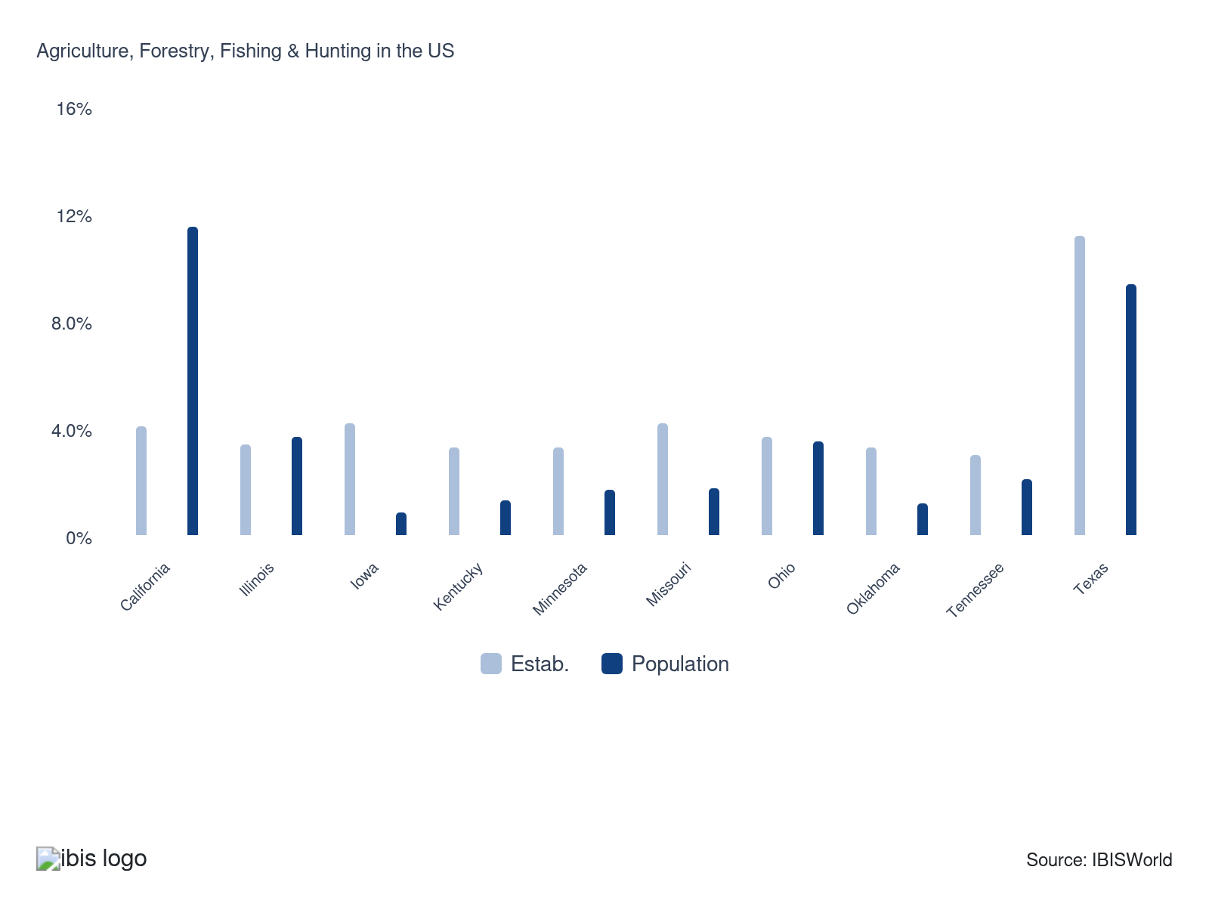

How do businesses use location to their advantage?
Appropriate climatic conditions
Some crops require unique climates or soil types and can only thrive in specific states, such as citrus in Florida, almonds in California, or cranberries in Wisconsin, limiting where certain agricultural businesses can operate.
Ensure irrigation water is available
Reliable water access, whether through rainfall, irrigation, or aquifer systems, is essential for crop health and stability, helping farmers withstand droughts and produce consistently high yields across growing seasons.

6. Competitive Forces
https://my.ibisworld.com/us/en/industry/11/competitive-forces

Key Takeaways
- Compliance with USDA standards is essential for farms selling in the US. Without meeting these regulatory benchmarks, farms can't distribute their agricultural products in the market, ensuring quality and safety for consumers.
- High supplier power, particularly for inputs like fertilizers, shapes terms and pricing in agriculture. Farmers negotiate supply contracts to mitigate input volatility, while buyers drive competition with quality and price demands.

Concentration
Low
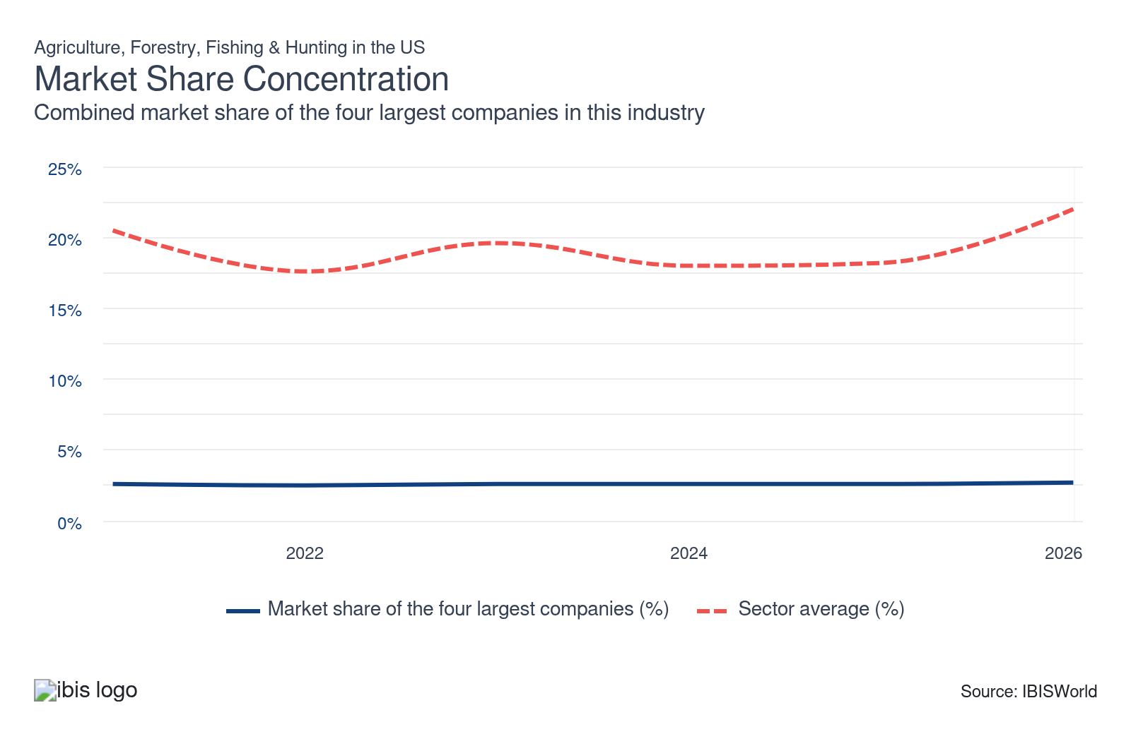

What impacts the industry’s market share concentration?

Most farms remain family owned, keeping market share concentration structurally low
- Family farms dominate the structure of US agriculture. The USDA’s latest typology from 2025 data shows family-owned operations account for 95.0% of all US farms, with small family farms making up the vast majority by count, operating a large share of farmland but generating a relatively modest share of total production value. This ownership pattern prevents the kind of extreme national concentration seen in input supply, processing and retail.
- Some subindustries are more concentrated, even though the farm sector itself remains diffuse. Agricultural support services such as custom harvesting, input retailing and large-scale advisory or data platforms are increasingly dominated by regional or national players, while segments like commercial fishing, hunting preserves and industrial forestry often feature a smaller number of larger firms with meaningful local or regional market power.

Supply chain structure hides concentration
- While the agriculture sector doesn’t show a high market share concentration, livestock production's supply chain structure can obscure true ownership. Large companies, such as Tyson Foods, and farming cooperatives play crucial roles without directly owning livestock farms, complicating the perception of market share concentration.
- Tyson Foods, for instance, supplies chickens and feed to thousands of independent farms, significantly influencing farm operations. This indirect control allows larger corporations to maintain substantial influence over the industry without direct farm ownership, affecting market dynamics and perceived market concentration.
- Many farms operate within co-ops. These agreements allow them to aggregate their buyer and supplier power, hold stronger control over prices, benefit from economies of scale and share in large contracts with food processors, crop services providers and more.

Consolidation is accelerating as farm numbers fall and acreage shifts
- Recent USDA “Farms and Land in Farms” reporting shows the number of US farms has been falling consistently in recent years. Between 2018 and 2025, total farmland dropped by 25 million acres while average farm size climbed to a record 469 acres, indicating land is concentrating into fewer operations.
- Farms with at least $500,000 in annual sales now control close to 50.0% of US farmland, despite representing less than 10.0% of farm operations, while 78.8% of farms generate under $100,000 in sales but control only about a quarter of farmland. Larger row-crop and livestock operations are expanding acreage and market share as smaller farms exit or are absorbed, structurally increasing concentration on the production side even though individual local markets may still look fragmented.

How do successful businesses handle concentration?
Secure economies of scale
This allows agricultural businesses to reduce production costs per unit by increasing output, making them more competitive in a concentrated market.
Develop a skilled labor force
Skilled workers enhance productivity and innovation, which is essential for maintaining competitiveness and efficiency in the agriculture sector.

Barriers to Entry
High | Increasing

What challenges do potential industry entrants face?

Legal
- Farms must ensure that their crop-growing and livestock-raising processes comply with USDA standards and cannot sell agricultural products in the US without meeting them. Product labeling is also highly regulated, and producers must abide by the growing and processing practices laid out by the USDA to market food products under labels such as organic.

Start-Up Costs
- Entrants to the sector must face steep initial investment costs, including acquiring large areas of land and supplies of specialized heavy machinery, agrochemicals, seeds, feed and more. Investment in effective irrigation systems has also become increasingly important as droughts become more frequent and severe with climate change.

Differentiation
- While commodities like corn, soybeans, cattle and timber are largely undifferentiated, branding and specialization increasingly shape competitive entry. New operations often pursue niches such as organic certification, grass-fed or regenerative livestock, agroforestry, direct-to-consumer sales or value-added processing to avoid competing solely on price.

Capital Expenses
- The agriculture sector has become increasingly capital-intensive as farm equipment has advanced. Purchasing and maintaining precision equipment to keep yields competitive can represent a substantial expense, particularly for small farms that cannot leverage economies of scale. Regular essential purchases of core inputs such as fertilizers, pesticides, seeds and breeding stock also keep spending high and access to financing crucial for industry businesses.

How can potential entrants overcome barriers to entry?
Operate in a location with appropriate water supply, soil type and climate
This ensures optimal crop growth and productivity, reducing costs and increasing yield reliability. It's essential for sustainable agricultural operations and mitigating environmental challenges.
Guarantee supply of key inputs
Depending on their specialty, farms need a reliable supply of seeds, fertilizer, livestock and other agricultural inputs. The quality of these inputs often has a direct effect on the quality of the farm's products.

Substitutes
Low | Steady

What are substitutes for industry services?

Imports
- Rising imports of horticultural and high-value foods act as a direct substitute for domestic crop, livestock and some forestry production, especially in off-season windows. Recent import gains have been driven by fruits, vegetables, nuts, wine and other consumer-ready products from Mexico, Canada, the EU and South America.
- These imports give retailers and foodservice buyers reliable, year-round alternatives to domestic output, weakening seasonal pricing power for US growers and livestock producers. Winter vegetable and fruit imports compete directly with Southeastern and California producers, while imported beef, dairy ingredients and processed foods can undercut domestic suppliers when exchange rates favor foreign sellers or when US input costs spike. In forestry, Canadian softwood lumber and other wood products fill gaps in US supply and effectively substitute for domestic timber and sawmill output.

Agriculture is the base of nearly all food
- Agricultural goods hold a unique position in the global market due to the limited availability of substitutes. This is largely because the vast majority of food consumed worldwide originates from the agriculture sector.
- Despite technological advancements leading to the development of lab-grown meat and an array of vitamin and mineral supplements, these innovations still fundamentally rely on plant-based ingredients. Consumer perception also remains a hurdle, with a 2022 study from the Journal of Environmental Psychology finding that 35.0% of meat-eaters and 55.0% of vegetarians believe cultured meat is "too disgusting to eat."

How do successful businesses compete with substitutes?
Invest in new technology to enhance operational efficiency and quality
In the agricultural sector, adopting new technologies can boost productivity and improve crop quality, helping to effectively compete against substitutes.
Develop a wide and expanding product range
This diversification reduces risk and allows farmers to respond flexibly to changing consumer demands, providing an edge over substitute products.

Buyer & Supplier Power
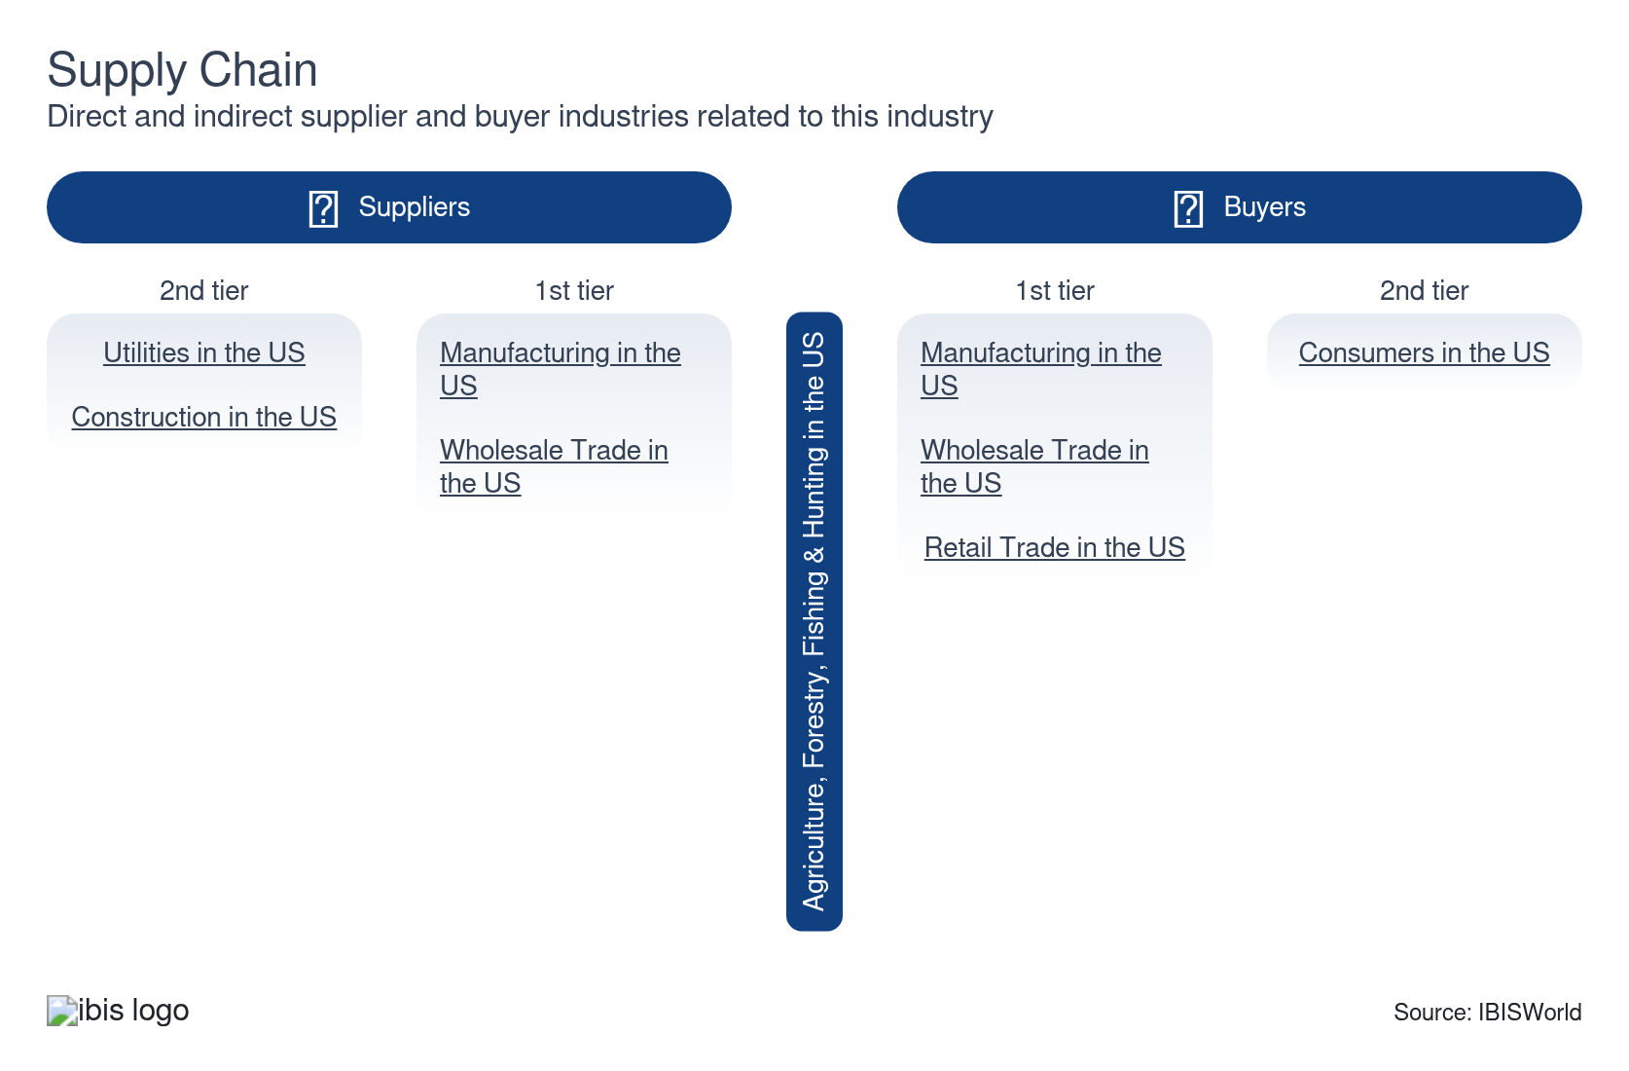

What power do buyers and suppliers have over the industry?

Buyers: Concentrated processors and retailers
Moderate | Steady
- Many producers in the agricultural sector sell into a small group of dominant downstream firms, such as Tyson Foods, JBS, Cargill and Smithfield/WH Group in meatpacking; ADM, Cargill, Bunge and Louis Dreyfus in grain handling and processing; and large manufacturers like Nestlé, PepsiCo and Kraft Heinz. This fragmentation at the farm level, compared with the consolidation among these buyers, gives them leverage over pricing and contract terms, especially for livestock, grains and specialty crops.
- On the retail side, national grocery chains, big box stores and major foodservice distributors control access to consumers. These firms often impose strict private-label specs, delivery and volume requirements, and can pass cost shocks upstream instead of absorbing them, squeezing profit for farms, fisheries and timber producers.

Suppliers: Market control
High | Steady
- Large suppliers of essential, specialized agricultural inputs, such as fertilizers, crop protectants and proprietary technology, hold substantial market power in the sector due to their high market shares and consolidated control. This dominance allows them to significantly influence terms of trade, input pricing and product access, often limiting the choices available to farmers. As a result, producers frequently have little leverage in negotiating supply contracts or comparing competing offers, which can impact input costs and operational flexibility.
- The dominance of GMO seed and agricultural machinery manufacturers in the seed and equipment markets narrows farmers' options, especially in regions where one or two firms command a strong local presence. Farmers with limited alternatives are often compelled to form long-term relationships or exclusive agreements with these suppliers, committing to their product ecosystems for several planting seasons. This arrangement can make it difficult to switch providers or adapt to market changes, reinforcing suppliers’ influence over farming practices, technology adoption and future input decisions.

How do successful businesses manage buyer & supplier power?
Establish supply contracts for key inputs
Volatile weather, disease and other unpredictable factors can disrupt supply chains and raise input prices. Having supply contracts can reduce this volatility.
Ensure appropriate pricing policy
Agricultural goods are commodities whose prices frequently fluctuate. To maintain a steady market for goods, agricultural companies must monitor price trends and keep prices competitive.

7. Companies
https://my.ibisworld.com/us/en/industry/11/companies

Key Takeaways
- Influential corporations like Tyson Foods shape farming operations indirectly. By supplying essentials like chickens and feed to independent farms, they exert substantial influence over the industry without directly owning the farms.
- Small, regional players make up the majority of the industry. While there is a high degree of consolidation among the sector's buyers and suppliers, including food processors, agrochemical producers and farm machinery manufacturers, this is not the case for farmers and agricultural service providers.

Market Share
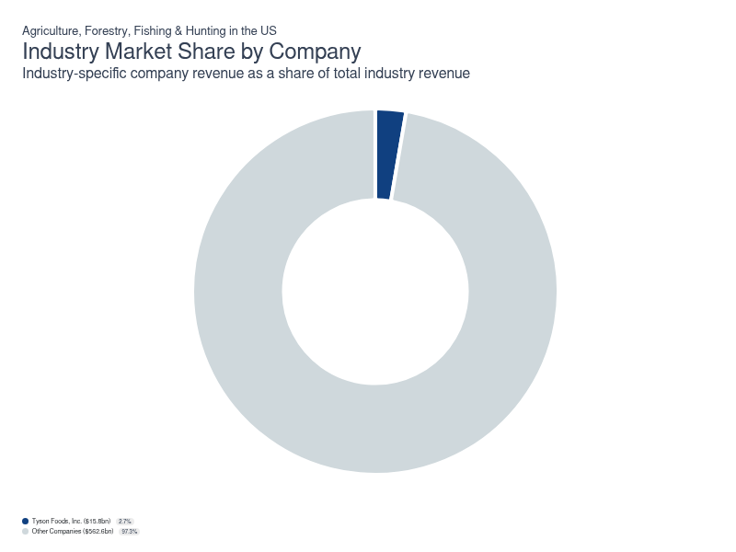
Chart displays current year only in the PDF version of this report. You can view and download chart for all other years associated with this industry on my.ibisworld.com.

Companies
Company | Market Share (%)  2026 | Revenue ($m)  2026 | Profit ($m)  2026 | Profit Margin (%)  2026
Tyson Foods, Inc. | 2.7 | 15,819.5 | 302.6 | 1.9

Tyson Foods, Inc.
Tyson Foods, Inc.
Company Details
Company Details
Industry Specific Revenue (2026) | $15.8bn
Industry Profit (2026) | $302.6m
Company Employees (2026) | 133,000
Market Share (2026) | 2.7%

Description
Description
Tyson Foods is a public company headquartered in Arkansas with an estimated 133,000 employees. In the US, the company has a notable market share in at least six industries: Agriculture, Forestry, Fishing & Hunting, Meat Processing, Tortilla Manufacturing, Chicken & Turkey Meat Production, Hot Dog & Sausage Production, Rendering & Meat Byproduct Processing and Tortilla Manufacturing. Their largest market share is in the Rendering & Meat Byproduct Processing industry, where they account for an estimated 50.6% of total industry revenue.

Brands and Trading Names
Brands and Trading Names
- Advancepierre Foods
- Big Az
- Bosco's Pizza
- Fast Fixin
- IBP
- Keystone Foods

Other Industries
Other Industries
- Chicken & Turkey Meat Production in the US
- Hot Dog & Sausage Production in the US
- Meat Processing in the US
- Rendering & Meat Byproduct Processing in the US
- Tortilla Manufacturing in the US

Company’s Industry Revenue, Market Share, and Profit Margin Over Time
Company’s Industry Revenue, Market Share, and Profit Margin Over Time
Year | Industry Revenue ($ million) | Market Share (%) | Profit Margin (%)
2021 | 12936 | 2.6 | 4.5
2022 | 15048 | 2.5 | 7.7
2023 | 14803 | 2.5 | -3.0
2024 | 14808 | 2.6 | 2.6
2025 | 15270 | 2.6 | 2.5
2026 | 15820 | 2.7 | 1.9

You can view and download company details on my.ibisworld.com.

8. External Environment
https://my.ibisworld.com/us/en/industry/11/external-environment

Key Takeaways
- The Farm Bill is a lifeline for many farmers facing low crop prices. This legislation provides crucial financial subsidies and regulations, helping stabilize the agricultural economy during challenging times.
- Three federal agencies play pivotal roles in agricultural regulation. The USDA, EPA and FDA collectively oversee areas like food safety, environmental protection and product quality, ensuring safe and sustainable farming practices nationwide.

External Drivers

What demographic and macroeconomic factors impact the industry?
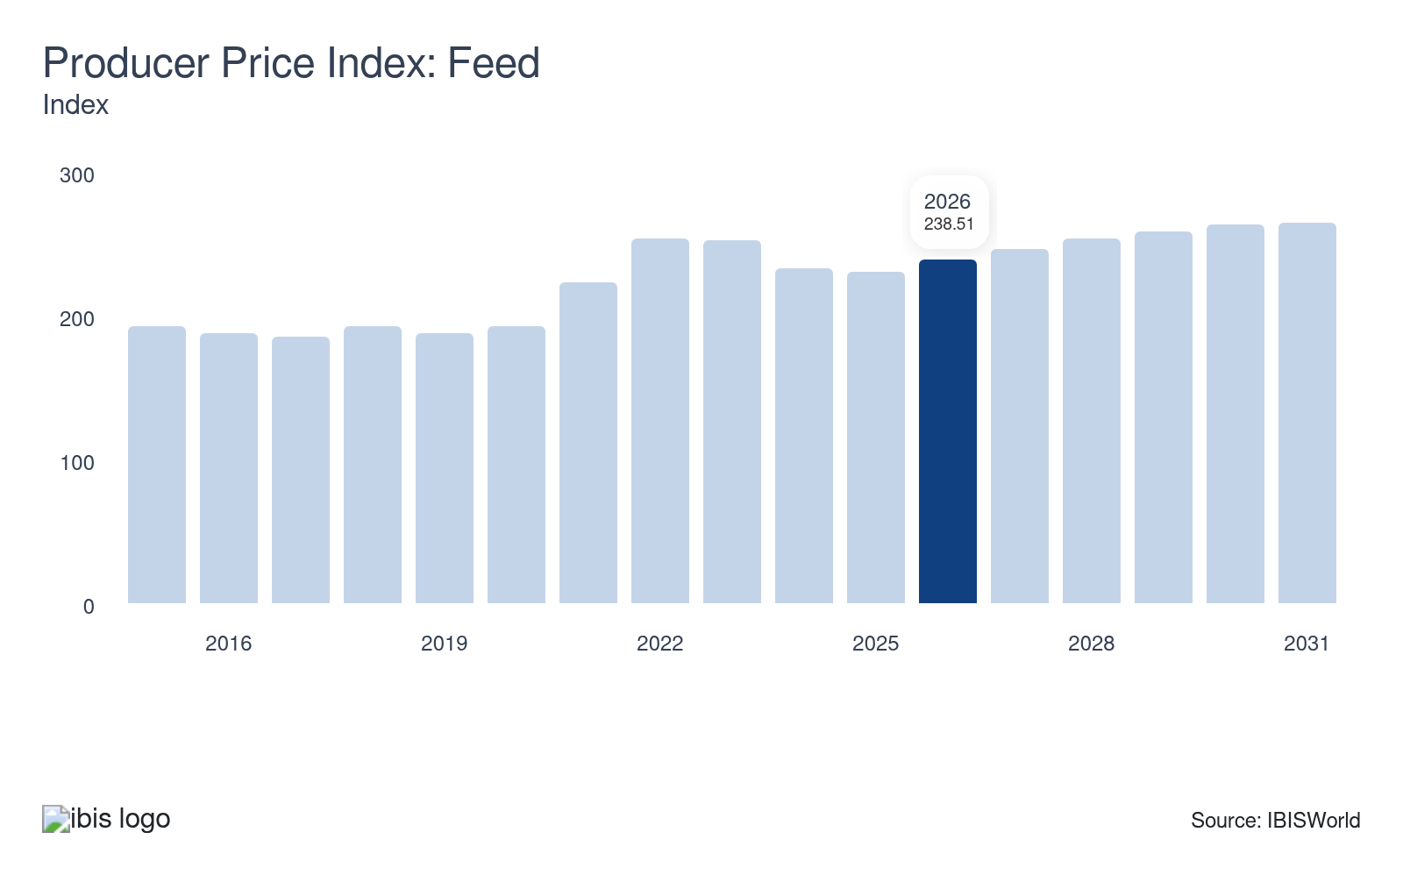
Feed is one of the largest input costs for livestock industries. As the price of feed increases, livestock producers pass the increased cost onto consumers, resulting in increased revenue. Additionally, livestock feed is produced by crop growers, so higher feed prices generate higher revenue for crop growers. Decreases in the price of feed pose a potential threat to industry revenue.
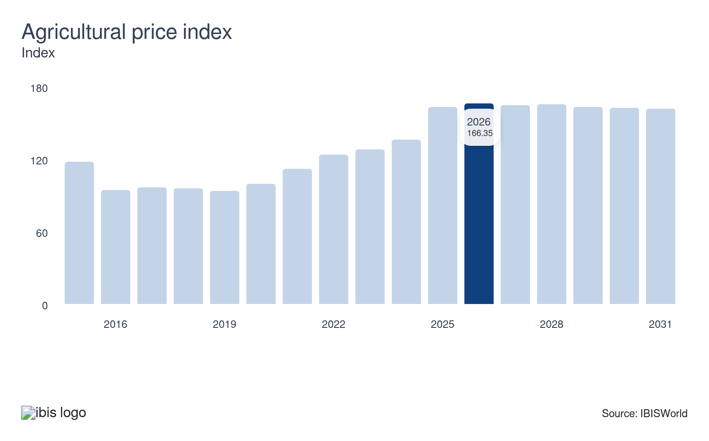
The agricultural price index serves as a comprehensive measure of the prices received for all agricultural products, including both crops and livestock. When this index sees an upward trend, it typically indicates that farms are generating more revenue from their products. This index acts as a strong indicator of overall sector performance, reflecting both market demand and the potential profitability of agricultural enterprises.
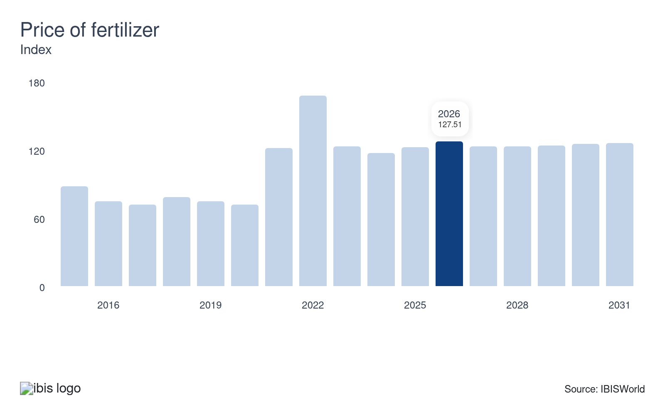
Fertilizer is a major input cost for crop growers because fertilizer is needed to grow crops. As fertilizer prices increase, crop growers are likely to pass cost increases onto buyers, resulting in increased revenue. The growth of the price of fertilizer presents a major opportunity for the agricultural industry revenue growth.
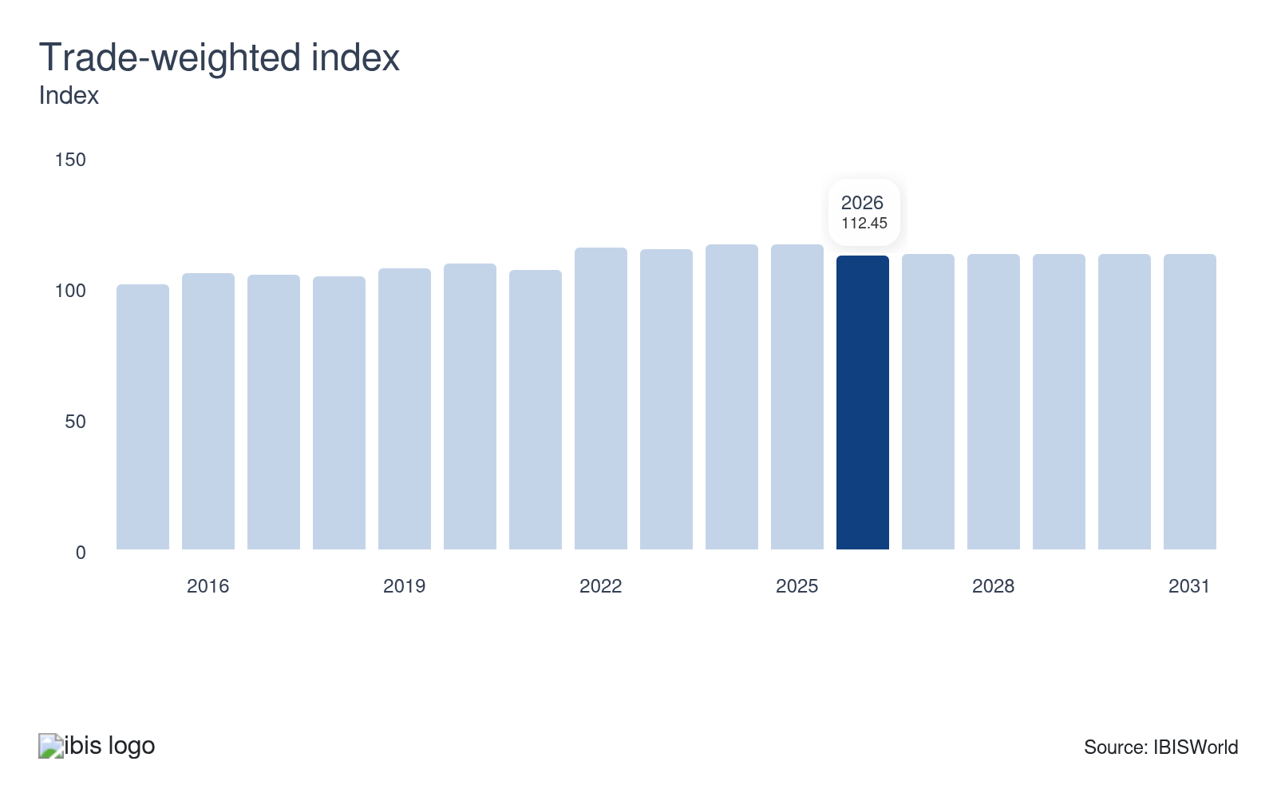
The trade-weighted index (TWI) assesses the value of the US dollar relative to the currencies of the United States’ largest trading partners. When the US dollar appreciates, foreign goods become relatively less expensive in the US market, leading to increased competition from imports. This shift can challenge domestic producers who may struggle to compete with the lower-priced foreign goods. Consequently, a stronger US dollar can have significant implications for domestic agricultural sectors, affecting export competitiveness.
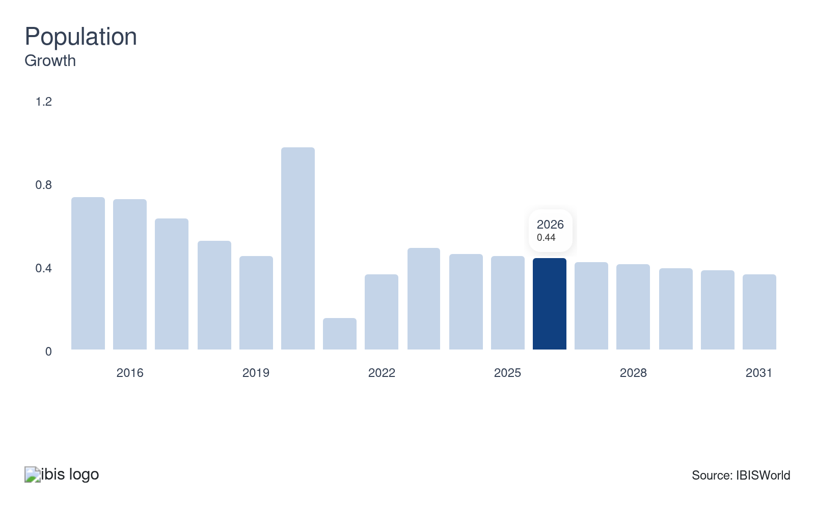
Population growth significantly drives revenue in the agricultural sector by expanding the consumer base and increasing demand for food products. As more people require sustenance, both crop and livestock producers see higher sales volumes. This rise in demand encourages investments in agricultural technologies and infrastructure, enhancing productivity and profitability. Ultimately, a growing population catalyzes economic growth within the agriculture industry, boosting revenue streams.

Regulation & Policy
High | Steady

What regulations impact the industry?

US Department of Agriculture
The USDA oversees the regulation of most animal-based agriculture operations in the US. This includes inspecting meat and poultry quality, setting safety and labeling standards, and regulating food safety for the highly perishable foods it oversees. The USDA does not set direct price limits on meat but instead ensures transparency and fair competition in meat markets through reporting and regulatory enforcement. Its purview includes meat, poultry and processed egg products (not shell eggs, which are regulated by the FDA), while most fish are excluded. The agency also controls the Center for Nutrition Policy and Promotion, which establishes dietary regulations and the Food and Nutrition Service, which manages supplemental nutrition programs.

The Environmental Protection Agency
The EPA provides crucial assistance to the agriculture sector through regulations that minimize environmental damage and protect consumer health. By overseeing the use of agricultural chemicals and pesticides, the EPA ensures adherence to safe levels of pesticide residues, safeguarding soil and water resources. Policies like the Clean Water Act and the Federal Insecticide, Fungicide and Rodenticide Act guide acceptable application techniques, controlling exposure and promoting sustainable farming practices. In 2025, new regulatory reforms have streamlined certain pesticide requirements while enhancing protections for water and endangered species.

The Food and Drug Administration
The FDA regulates most food products consumed in the United States. The agency sets and enforces regulations related to the growing, harvesting, processing, packaging, storing and transporting of all food products besides meat and some animal products. The FDA employs consistent inspections, product testing and process tracking at production facilities. The FDA considers nutritional facts' authenticity, latent allergen data or any ingredient misrepresentation. Furthermore, the FDA has the authority to mandate a food recall to protect consumers.

Forest Service and federal forest management
Federal statutes such as the National Forest Management Act and related regulations govern logging and other commercial activities on national forests, which are managed by the US Forest Service under the USDA. These rules require the agency to prepare forest plans, balance timber harvesting with conservation, recreation and wildlife, and comply with environmental review under the National Environmental Policy Act. For forestry and logging companies, this framework shapes access to federal timber through timber sale contracts, dictates harvest methods and seasonal restrictions, and can limit activity in sensitive habitats or roadless areas. Recent controversies over national timber targets illustrate how federal planning decisions can expand or constrain logging opportunities over multi-year horizons.

Wildlife, hunting and fishing regulations
Wildlife-related businesses operate within a dense framework of federal and state rules, including the Endangered Species Act (ESA), Migratory Bird Treaty Act (MBTA), Magnuson-Stevens Act for marine fisheries and state game and fish codes. These laws govern hunting seasons and bag limits, protected species, habitat protections and licensing requirements, directly affecting outfitters, fee-hunting operations and commercial fisheries. The US Fish and Wildlife Service and state wildlife agencies issue permits for activities that could affect protected species, such as incidental take permits or special use authorizations.

Assistance
High | Steady

What assistance is available to this industry?

Farm Bill safety-net and subsidy programs
Federal farm programs deliver direct income support and risk management tools to crop and livestock producers through mechanisms like Price Loss Coverage (PLC), Agricultural Risk Coverage (ARC), dairy margin coverage, ad hoc disaster aid and marketing assistance loans. These programs stabilize revenue when commodity prices or farm-level revenues fall below legislated benchmarks, which is critical for capital-intensive row crop, livestock and specialty operations. PLC and ARC payments, along with marketing loans, underpin cashflow for grain, cotton and oilseed farms, while dairy margin coverage buffers small and midsize dairies against feed-cost spikes. In practice, these supports can influence planting decisions, sustain production on marginal land and reduce exit risk during downturns for farms across the agriculture, forestry, fishing and hunting sector.

Federal crop insurance
The Federal Crop Insurance Program, run by USDA’s Risk Management Agency and Federal Crop Insurance Corporation, subsidizes a substantial share of farmers’ insurance premiums, making multi-peril yield and revenue coverage affordable for producers. Policies cover major field crops, specialty crops, forage and some livestock revenue, protecting against yield losses from weather events, disease, and market price declines. This risk transfer mechanism underpins lending decisions and enables producers to invest in higher-yield technologies when they know downside risk is capped. Large-scale corn, soybean, wheat, cotton, dairy and hog operations capture a significant share of indemnities, but specialty-crop, forage and pasture products also support diversified farms and ranches.

Conservation Reserve Program (CRP)
The Conservation Reserve Program (CRP), administered by the United States Department of Agriculture (USDA), incentivizes farmers to retire environmentally sensitive land from active agricultural production. Instead, these lands are planted with species that enhance ecological health. This initiative is beneficial for the forestry and logging subsectors as it encourages sustainable land use practices. Currently, the USDA is allocating over $1.7 billion to participants in the program, highlighting the significant investment in promoting long-term environmental stewardship and sustainability across agricultural landscapes.

Grants, loans and support for small and midsize producers
The USDA provides targeted grants, direct loans and loan guarantees to small and midsize farmers, ranchers and forest landowners to expand production, adopt conservation practices and access new markets. Programs span farm ownership and operating loans, value-added producer grants and initiatives like StrikeForce for Rural Growth and Opportunity that channel resources into persistent-poverty rural areas. Complementary efforts such as Farm to School, seasonal high tunnel cost-share and local food systems initiatives help smaller crop and livestock producers sell into institutional and regional markets, improving profit and demand stability. These tools are particularly important for diversified farms, specialty crop growers and operators of mixed farm–recreation properties that may lack collateral or scale to secure purely commercial finance.

Public conservation and habitat support
Conservation provisions in the federal Farm Bill, alongside state and Tribal habitat programs, incentivize landowners to manage agricultural and forest lands for wildlife, water quality and outdoor recreation. Cost-share and rental payments support wetland restoration, forest stand improvement, riparian buffers and grassland establishment, which enhance game populations and fish habitat on private lands used for guided hunting, fee-access fishing and outdoor tourism. Groups representing sportsmen and conservation organizations advocate for strong Conservation and Forestry titles because they link farm and forest assistance directly to improved hunting and angling opportunities, increasing the economic viability of landowners who monetize recreational access alongside traditional agriculture or timber.

Industry associations
Industry associations like the American Farm Bureau Federation (AFBF) and the National Farmers Union (NFU) offer vital support to the agriculture sector. These organizations serve as advocates for farmers' interests at the state and national levels, influencing policy decisions that impact their livelihoods. They provide a unified voice for the diverse needs of farmers, representing them in discussions on issues such as trade, regulations and conservation. Furthermore, industry associations offer resources such as educational programs, market information and networking opportunities, aiding farmers in improving their business practices and adapting to changing market conditions. These associations are essential in shaping agricultural policy and promoting the long-term sustainability of farming.

Specialized financing for modernizing farm equipment
Access to modern farm machinery is essential for boosting productivity and efficiency, but the high cost can be a barrier for many agricultural businesses. Specialized financing options, like equipment loans and leases from John Deere Financial and Farm Credit Mid-America, provide farmers with flexible solutions to acquire necessary equipment without significant upfront capital. These programs offer competitive rates, tailored repayment plans and the ability to upgrade equipment regularly. Government-backed options, such as the Farm Service Agency (FSA) loans, further support new or small operations by providing low-interest financing.

9. Financial Benchmarks
https://my.ibisworld.com/us/en/industry/11/financial-benchmarks
Profit Margin  20.7 %  ↑ Higher than sector | Average Wage  $17,736  ↓ Lower than sector | Largest Cost  Purchases  31.7% of Revenue

Key Takeaways
- Farmers have struggled to maintain profit in the face of high input costs. As agricultural prices have deflated, the prices of core purchase expenses have not dropped as steeply.
- Chronic labor shortages continue to challenge the agricultural sector, driving costs up and limiting production volumes at times. With rising wages and tighter labor pools, farms are increasingly turning to automation and innovative solutions.
- Persisting utility cost increases strain agricultural budgets, with energy-intensive operations facing significant impacts. Droughts drive up water expenses, further stressing the cost structure of farms.

Cost Structure
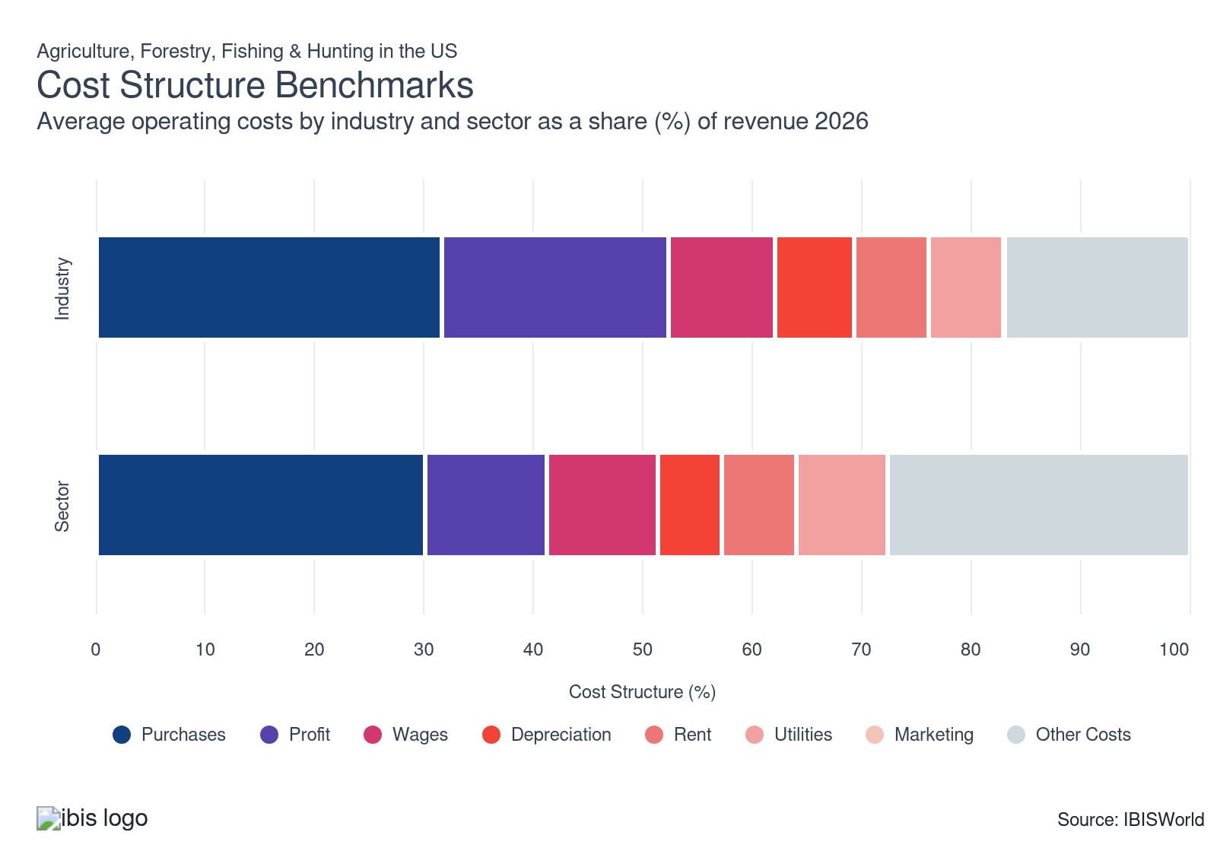
Chart displays current year only in the PDF version of this report. You can view and download chart for all other years associated with this industry on my.ibisworld.com.

What trends impact industry costs?

Profit in the agriculture sector has faced pressure amid elevated input costs
- Agricultural sector profits have been volatile, with net farm income peaking in 2022 and then trending lower as rising expenses outpaced softening revenues. USDA now estimates net farm income at 154.6 billion dollars in 2025, down dramatically from its 2022 high, and projects a further slight decline to 153.4 billion dollars in 2026, even as net cash farm income inches up.
- Driven by driven by weaker prices for commodities like soybeans and wheat, as large global harvests have increased supplies, farmer incomes declined in 2023 and 2024. Meanwhile, input costs remain elevated, with farmers reporting significant increases in expenses for seeds, fertilizer and equipment repairs.
- Reduced profit is challenging farmers' ability to reinvest in their operations and maintain financial stability, causing many to delay or scale back capital improvements, technology upgrades and expansion plans. This cautious posture could weigh on productivity growth and risk management capacity in the 2025/26 and 2026/27 marketing years, particularly if another round of weather or market shocks hits before balance sheets fully recover.

Purchase costs have softened but remain oppressive due to global supply chain disruptions and inflationary pressures
- Input costs for US farmers, such as fertilizers, seeds and agrochemicals, remain historically elevated, but most have stabilized or declined moderately from their 2021–2022 peaks; recent years have brought some relief, especially for fuel and fertilizer.
- Despite this cooling, production expenses are still projected to be well above their long-run average in 2025 and 2026. Crude oil prices and global logistics continue to influence input prices, but recent volatility is less pronounced than during the 2021–2022 spikes; costs for fuel are lower than their high points, even as machinery, repairs and labor remain expensive. This mix has encouraged producers to focus more on precision input use and maintenance strategies to stretch existing equipment and reduce waste rather than relying solely on cheaper inputs.
- The price impact from the Russia-Ukraine conflict persists in certain fertilizer and grain markets, but supply chain adjustments and expanded production elsewhere have curbed the worst fertilizer price spikes. High crop prices previously elevated seed and feed costs, but as crop prices have softened, pressure on some input categories has eased slightly, though overall profit for producers remains tight given broad-based cost increases.

Farm wages have climbed rapidly in recent years, pushed up by labor shortages
- The hired farm workforce continues to age, as fewer young immigrants enter agriculture and more workers settle permanently in specific regions instead of following crops. The USDA’s 2025 farm labor analyses show that the average age of foreign-born hired farmworkers has risen steadily since the mid-2000s, while the age of US-born workers has stayed relatively flat, pulling up the overall workforce age and reinforcing concerns about long-term labor supply.
- Use of the H-2A temporary agricultural worker program continues to expand rapidly, and wage rules tied to the Adverse Effect Wage Rate (AEWR) have made H-2A labor particularly costly for many employers. Farm Bureau analysis notes that program use continued to grow through 2025, while recent federal rule changes – set to take effect from 2026 – are expected to alter how those wages are calculated, potentially slowing future wage growth but also creating more uncertainty and complexity in how farm labor costs will evolve.

Capital needs stay high even as farm depreciation gently eases
- Agricultural services and farm operations have become increasingly capital-intensive over the past decade, as harvesting, planting, feeding and milking equipment have become more automated and digitally enabled. Large machinery, precision implements and on-farm storage and handling systems remain critical to maintaining productivity and managing labor constraints.
- While some farms share resources to reduce total capital expenditure, and high interest rates in 2023 and 2024 encouraged many producers to delay big-ticket purchases, depreciation costs remain substantial but have edged down from 2021. The USDA’s production expense data show capital consumption stabilizing or declining modestly in recent years in real terms, reflecting a plateau in large machinery purchases, longer replacement cycles and more selective investment in high-ROI technologies.

Utility expenses are stable overall but have hit energy-intensive operations hard
- Utility costs in the agricultural sector have been relatively stable at the aggregate level from 2021 to 2026, with electricity and fuel expenses fluctuating around elevated but not continuously rising levels. Overall, the USDA’s production expense categories show utility-related outlays holding roughly steady in real terms, even as individual operations experience significant variability based on location, energy mix and production system.
- Rising global electricity demand, data-center growth and geopolitical tensions affecting oil supply have contributed to periodic spikes in power and fuel prices, but investments in efficiency and on-farm energy management have helped many producers limit sustained cost escalation. Larger farms and specialized operations have increasingly adopted energy-efficient motors, LED lighting, variable-speed drives and, in some cases, on-farm solar or biogas systems to reduce exposure to grid and fuel price volatility.
- Livestock operations, particularly those with climate-controlled facilities like poultry and hog farms and greenhouse or controlled-environment agriculture operations, require significant energy for heating, cooling, lighting and ventilation systems and have been hit particularly hard by any utility cost increases. In contrast, extensive grazing systems and rainfed crop farms tend to face lower direct utility burdens, though drought-related increases in irrigation pumping can still create localized spikes during dry years.

High yields and declining rural populations allow revenue to outpace rent costs
- Agricultural land rental expenses have evolved between 2021 and 2026, with cash rents for high-quality cropland generally rising alongside strong land values, while rents in some marginal or depopulating rural areas have softened.
- Steady increases in average crop yields and high livestock and poultry prices have allowed many farmers to generate more revenue per acre or per facility, which in several regions has enabled revenue growth to outpace rent costs despite rising cash rents. This has helped keep rent’s share of total expenses relatively stable or even slightly lower for some farm businesses, though heavily leveraged or fully cash-rented operations remain vulnerable to any renewed downturn in prices or yields.

Marketing costs remain low as farmers focus on existing relationships
- Marketing costs represent a limited portion of industry farmers' and service providers' revenue and have decreased somewhat over the current period as revenue has grown faster than marketing spend.
- This low marketing spend is typical for B2B-focused industries but lags behind other sectors because of agriculture's particularly relationship-based sales model. Because the industry is highly fragmented, most farmers' sales come from regional relationships and contracts with processors, with most marketing spending coming from these manufacturers or from the co-ops representing farms.
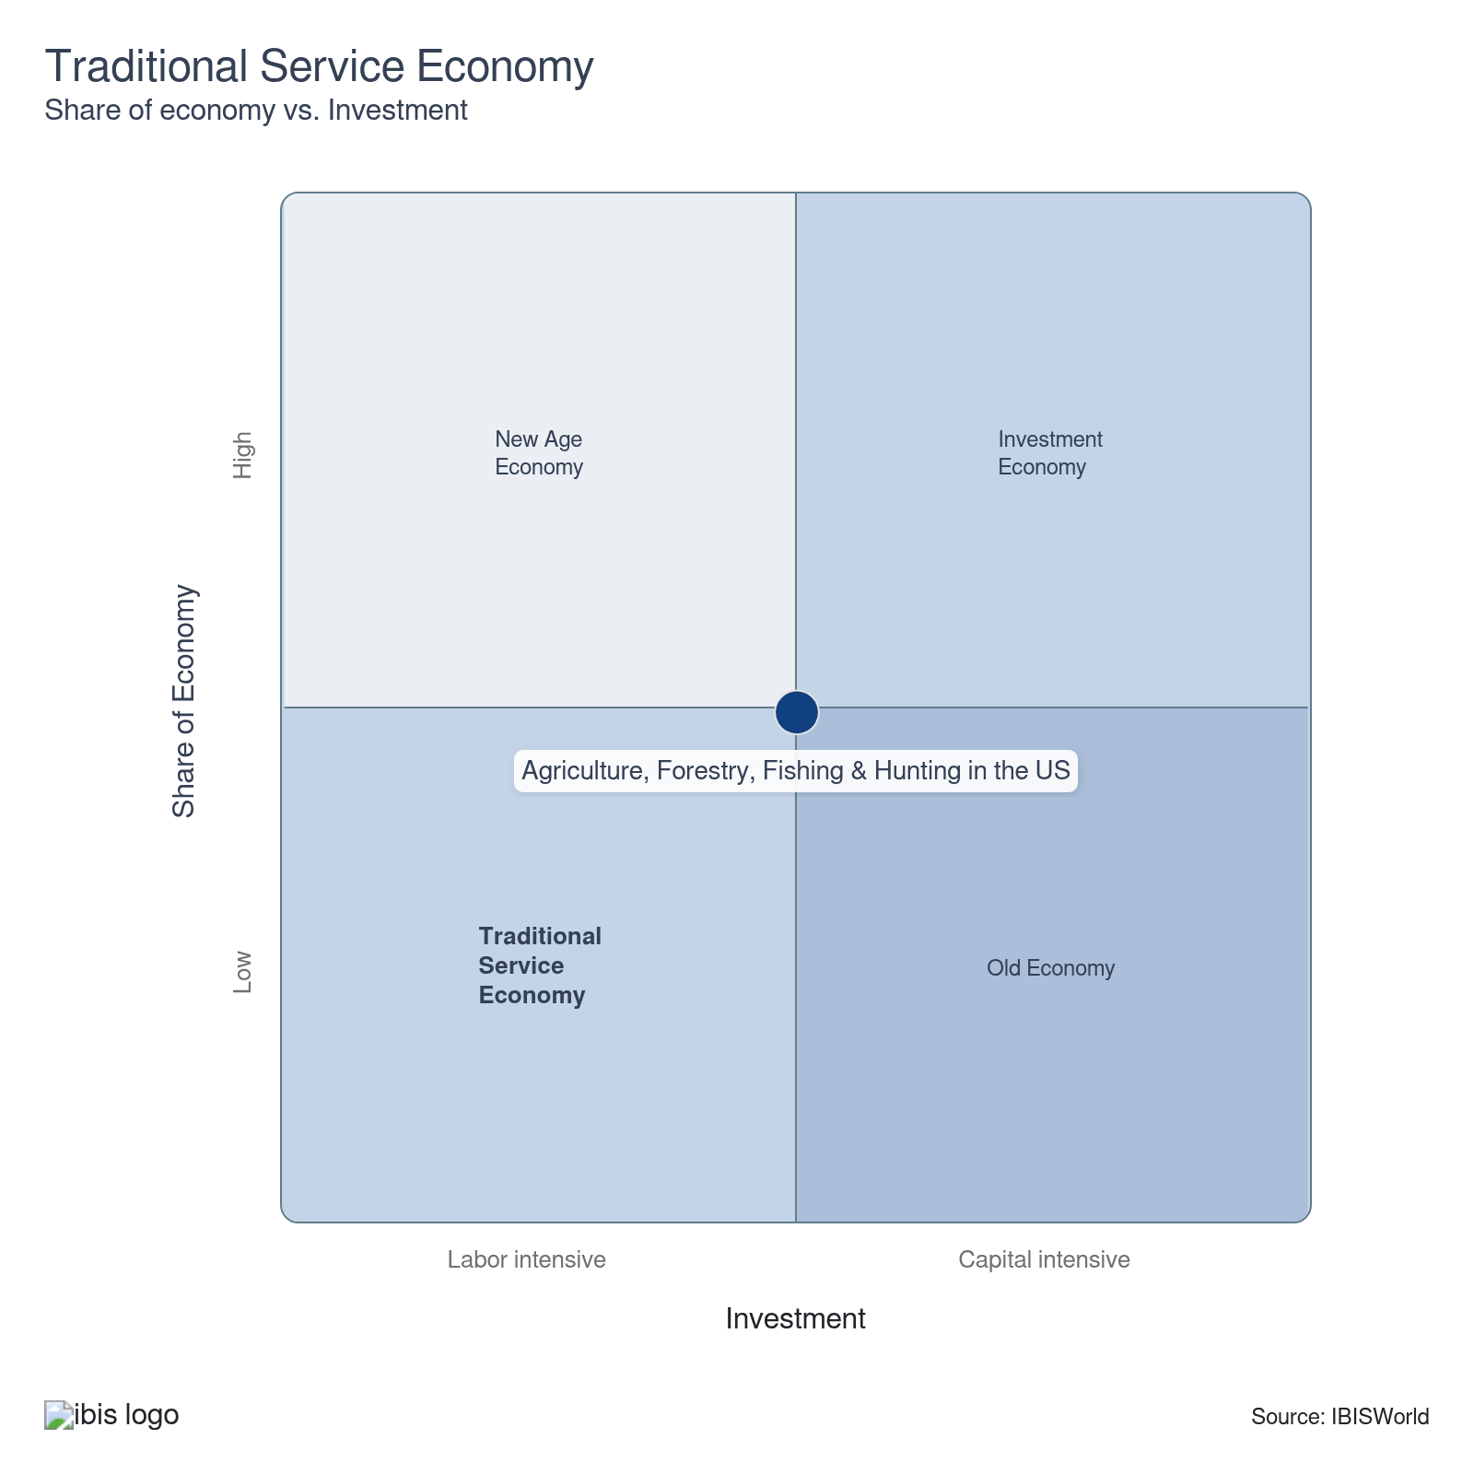

Key Ratios
Year | Revenue per Employee  ($) | Revenue per Enterprise  ($ Million) | Employees per Estab.  (Units) | Employees per Enterprise  (Units) | Average Wage  ($) | Wages/ Revenue  (%) | Estab. per Enterprise  (Units) | IVA/ Revenue  (%) | Imports/ Demand  (%) | Exports/ Revenue  (%)
2007 | 149,200 | 0.2 | 1.4 | 1.4 | 14,581 | 9.8 | 1.0 | 36.4 | 11.3 | 15.3
2008 | 155,972 | 0.2 | 1.4 | 1.4 | 14,291 | 9.2 | 1.0 | 33.2 | 11.9 | 18.4
2009 | 141,672 | 0.2 | 1.4 | 1.4 | 13,571 | 9.6 | 1.0 | 32.3 | 11.5 | 16.5
2010 | 150,440 | 0.2 | 1.4 | 1.4 | 12,443 | 8.3 | 1.0 | 34.4 | 12.5 | 18.1
2011 | 164,564 | 0.2 | 1.4 | 1.4 | 11,653 | 7.1 | 1.0 | 35.2 | 13.6 | 19.5
2012 | 175,846 | 0.3 | 1.5 | 1.5 | 13,620 | 7.7 | 1.0 | 38.9 | 12.4 | 17.9
2013 | 176,515 | 0.3 | 1.5 | 1.5 | 13,718 | 7.8 | 1.0 | 40.1 | 12.7 | 17.1
2014 | 185,377 | 0.3 | 1.5 | 1.5 | 14,658 | 7.9 | 1.0 | 38.0 | 12.8 | 16.8
2015 | 166,536 | 0.2 | 1.5 | 1.5 | 13,801 | 8.3 | 1.0 | 37.6 | 13.4 | 16.1
2016 | 159,384 | 0.2 | 1.5 | 1.5 | 14,896 | 9.3 | 1.0 | 37.9 | 14.4 | 17.7
2017 | 165,600 | 0.2 | 1.5 | 1.5 | 15,808 | 9.5 | 1.0 | 36.8 | 14.6 | 17.2
2018 | 161,030 | 0.2 | 1.5 | 1.5 | 14,498 | 9.0 | 1.0 | 33.9 | 14.8 | 17.0
2019 | 155,466 | 0.2 | 1.5 | 1.5 | 14,493 | 9.3 | 1.0 | 35.1 | 15.1 | 16.4
2020 | 151,860 | 0.2 | 1.5 | 1.5 | 15,544 | 10.2 | 1.0 | 37.9 | 15.6 | 18.4
2021 | 172,612 | 0.3 | 1.5 | 1.5 | 13,996 | 8.1 | 1.0 | 37.4 | 15.7 | 18.5
2022 | 201,949 | 0.3 | 1.5 | 1.5 | 15,368 | 7.6 | 1.0 | 34.5 | 14.1 | 17.0
2023 | 186,166 | 0.3 | 1.5 | 1.5 | 17,280 | 9.3 | 1.0 | 36.4 | 13.5 | 14.7
2024 | 184,774 | 0.3 | 1.5 | 1.5 | 17,872 | 9.7 | 1.0 | 38.1 | 14.3 | 14.5
2025 | 185,982 | 0.3 | 1.5 | 1.5 | 17,779 | 9.6 | 1.0 | 38.4 | 14.0 | 13.4
2026 | 183,759 | 0.3 | 1.5 | 1.5 | 17,736 | 9.7 | 1.0 | 37.7 | 13.9 | 13.6
2027 | 185,594 | 0.3 | 1.5 | 1.5 | 17,772 | 9.6 | 1.0 | 37.7 | 13.8 | 13.6
2028 | 187,340 | 0.3 | 1.5 | 1.5 | 17,805 | 9.5 | 1.0 | 37.6 | 13.8 | 13.7
2029 | 188,890 | 0.3 | 1.5 | 1.6 | 17,835 | 9.4 | 1.0 | 37.5 | 13.8 | 13.7
2030 | 190,078 | 0.3 | 1.6 | 1.6 | 17,857 | 9.4 | 1.0 | 37.4 | 13.8 | 13.7
2031 | 190,702 | 0.3 | 1.6 | 1.6 | 17,869 | 9.4 | 1.0 | 37.5 | 13.8 | 13.6
2032 | 191,630 | 0.3 | 1.6 | 1.6 | 17,886 | 9.3 | 1.0 | 37.5 | 13.8 | 13.6
*Figures are inflation adjusted to 2026
*Figures are inflation adjusted to 2026

10. Key Statistics
https://my.ibisworld.com/us/en/industry/11/key-statistics

Industry Data

Values
Year | Revenue  ($ Million) | IVA  ($ Million) | Estab.  (Units) | Enterprises  (Units) | Employment  (Units) | Exports  ($ Million) | Imports  ($ Million) | Wages  ($ Million)
2007 | 527,455.2 | 191,760.8 | 2,464,492 | 2,460,783 | 3,535,219 | 80,770.8 | 56,886.4 | 51,545.3
2008 | 551,416.5 | 182,977.6 | 2,461,682 | 2,457,989 | 3,535,366 | 101,220.0 | 60,789.8 | 50,523.5
2009 | 497,498.7 | 160,511.1 | 2,464,436 | 2,460,773 | 3,511,628 | 81,952.2 | 54,145.4 | 47,654.7
2010 | 529,559.2 | 182,308.1 | 2,468,219 | 2,464,554 | 3,520,077 | 95,598.4 | 62,056.6 | 43,798.6
2011 | 578,152.0 | 203,768.8 | 2,448,510 | 2,444,778 | 3,513,238 | 112,728.8 | 73,185.5 | 40,939.6
2012 | 609,241.1 | 237,123.1 | 2,371,403 | 2,367,454 | 3,464,629 | 109,262.4 | 70,722.5 | 47,188.8
2013 | 614,391.8 | 246,113.7 | 2,368,433 | 2,364,359 | 3,480,680 | 105,030.0 | 74,147.1 | 47,746.3
2014 | 645,484.7 | 245,548.9 | 2,351,183 | 2,346,901 | 3,482,017 | 108,480.3 | 79,024.6 | 51,038.7
2015 | 580,113.6 | 218,143.7 | 2,336,350 | 2,331,885 | 3,483,415 | 93,432.8 | 75,404.4 | 48,074.7
2016 | 556,069.1 | 210,482.9 | 2,332,809 | 2,328,223 | 3,488,869 | 98,152.2 | 76,898.9 | 51,969.4
2017 | 575,127.1 | 211,434.4 | 2,316,120 | 2,311,410 | 3,472,988 | 98,868.9 | 81,257.0 | 54,902.4
2018 | 558,150.7 | 189,039.6 | 2,308,438 | 2,303,572 | 3,466,134 | 94,674.5 | 80,695.9 | 50,252.1
2019 | 538,662.6 | 189,137.6 | 2,308,657 | 2,303,698 | 3,464,820 | 88,335.6 | 79,917.9 | 50,216.7
2020 | 522,839.1 | 198,319.7 | 2,310,520 | 2,305,400 | 3,442,909 | 96,166.6 | 78,598.1 | 53,518.2
2021 | 595,005.7 | 222,643.1 | 2,309,484 | 2,304,208 | 3,447,070 | 110,081.3 | 90,253.4 | 48,245.0
2022 | 673,238.1 | 232,532.4 | 2,187,567 | 2,181,795 | 3,333,705 | 114,591.1 | 91,324.1 | 51,230.9
2023 | 618,571.2 | 225,207.9 | 2,184,676 | 2,178,707 | 3,322,679 | 90,940.0 | 82,595.4 | 57,415.2
2024 | 599,622.6 | 228,739.3 | 2,145,874 | 2,141,861 | 3,245,174 | 87,107.6 | 85,320.8 | 57,998.0
2025 | 605,926.7 | 232,485.0 | 2,141,146 | 2,135,333 | 3,257,991 | 81,476.5 | 85,313.5 | 57,924.6
2026 | 578,408.3 | 218,106.0 | 2,088,766 | 2,086,054 | 3,147,652 | 78,554.6 | 80,367.7 | 55,827.5
2027 | 588,671.2 | 221,677.9 | 2,086,013 | 2,080,678 | 3,171,828 | 80,332.0 | 81,277.1 | 56,368.7
2028 | 598,712.1 | 225,278.2 | 2,082,310 | 2,074,362 | 3,195,864 | 81,753.2 | 82,595.5 | 56,902.7
2029 | 607,058.9 | 227,578.4 | 2,075,783 | 2,065,452 | 3,213,819 | 82,944.7 | 83,678.1 | 57,317.1
2030 | 615,456.5 | 230,325.7 | 2,078,021 | 2,065,852 | 3,237,911 | 84,144.6 | 84,765.8 | 57,819.4
2031 | 618,776.7 | 231,934.9 | 2,073,674 | 2,060,406 | 3,244,736 | 84,293.3 | 85,628.9 | 57,979.3
2032 | 627,177.6 | 235,347.4 | 2,078,909 | 2,063,955 | 3,272,858 | 85,370.7 | 86,881.1 | 58,538.7

*Figures are inflation adjusted to 2026

Annual Change
Year | Revenue  % | IVA  % | Estab.  % | Enterprises  % | Employment  % | Exports  % | Imports  % | Wages  %
2007 | N/A | N/A | N/A | N/A | N/A | N/A | N/A | N/A
2008 | 4.5 | -4.6 | -0.1 | -0.1 | 0.0 | 25.3 | 6.9 | -2.0
2009 | -9.8 | -12.3 | 0.1 | 0.1 | -0.7 | -19.0 | -10.9 | -5.7
2010 | 6.4 | 13.6 | 0.2 | 0.2 | 0.2 | 16.7 | 14.6 | -8.1
2011 | 9.2 | 11.8 | -0.8 | -0.8 | -0.2 | 17.9 | 17.9 | -6.5
2012 | 5.4 | 16.4 | -3.1 | -3.2 | -1.4 | -3.1 | -3.4 | 15.3
2013 | 0.8 | 3.8 | -0.1 | -0.1 | 0.5 | -3.9 | 4.8 | 1.2
2014 | 5.1 | -0.2 | -0.7 | -0.7 | 0.0 | 3.3 | 6.6 | 6.9
2015 | -10.1 | -11.2 | -0.6 | -0.6 | 0.0 | -13.9 | -4.6 | -5.8
2016 | -4.1 | -3.5 | -0.2 | -0.2 | 0.2 | 5.1 | 2.0 | 8.1
2017 | 3.4 | 0.5 | -0.7 | -0.7 | -0.5 | 0.7 | 5.7 | 5.6
2018 | -3.0 | -10.6 | -0.3 | -0.3 | -0.2 | -4.2 | -0.7 | -8.5
2019 | -3.5 | 0.1 | 0.0 | 0.0 | 0.0 | -6.7 | -1.0 | -0.1
2020 | -2.9 | 4.9 | 0.1 | 0.1 | -0.6 | 8.9 | -1.7 | 6.6
2021 | 13.8 | 12.3 | 0.0 | -0.1 | 0.1 | 14.5 | 14.8 | -9.9
2022 | 13.1 | 4.4 | -5.3 | -5.3 | -3.3 | 4.1 | 1.2 | 6.2
2023 | -8.1 | -3.1 | -0.1 | -0.1 | -0.3 | -20.6 | -9.6 | 12.1
2024 | -3.1 | 1.6 | -1.8 | -1.7 | -2.3 | -4.2 | 3.3 | 1.0
2025 | 1.1 | 1.6 | -0.2 | -0.3 | 0.4 | -6.5 | 0.0 | -0.1
2026 | -4.5 | -6.2 | -2.4 | -2.3 | -3.4 | -3.6 | -5.8 | -3.6
2027 | 1.8 | 1.6 | -0.1 | -0.3 | 0.8 | 2.3 | 1.1 | 1.0
2028 | 1.7 | 1.6 | -0.2 | -0.3 | 0.8 | 1.8 | 1.6 | 0.9
2029 | 1.4 | 1.0 | -0.3 | -0.4 | 0.6 | 1.5 | 1.3 | 0.7
2030 | 1.4 | 1.2 | 0.1 | 0.0 | 0.7 | 1.4 | 1.3 | 0.9
2031 | 0.5 | 0.7 | -0.2 | -0.3 | 0.2 | 0.2 | 1.0 | 0.3
2032 | 1.4 | 1.5 | 0.3 | 0.2 | 0.9 | 1.3 | 1.5 | 1.0

*Figures are inflation adjusted to 2026

DISCLAIMER
This product has been supplied by IBISWorld Inc. (‘IBISWorld’) solely for use by its authorized licenses strictly in accordance with their license agreements with IBISWorld. IBISWorld makes no representation to any other person with regard to the completeness or accuracy of the data or information contained herein, and it accepts no responsibility and disclaims all liability (save for liability which cannot be lawfully disclaimed) for loss or damage whatsoever suffered or incurred by any other person resulting from the use of, or reliance upon, the data or information contained herein. Copyright in this publication is owned by IBISWorld Inc. The publication is sold on the basis that the purchaser agrees not to copy the material contained within it for other than the purchasers own purposes. In the event that the purchaser uses or quotes from the material in this publication – in papers, reports, or opinions prepared for any other person – it is agreed that it will be sourced to: IBISWorld Inc.

